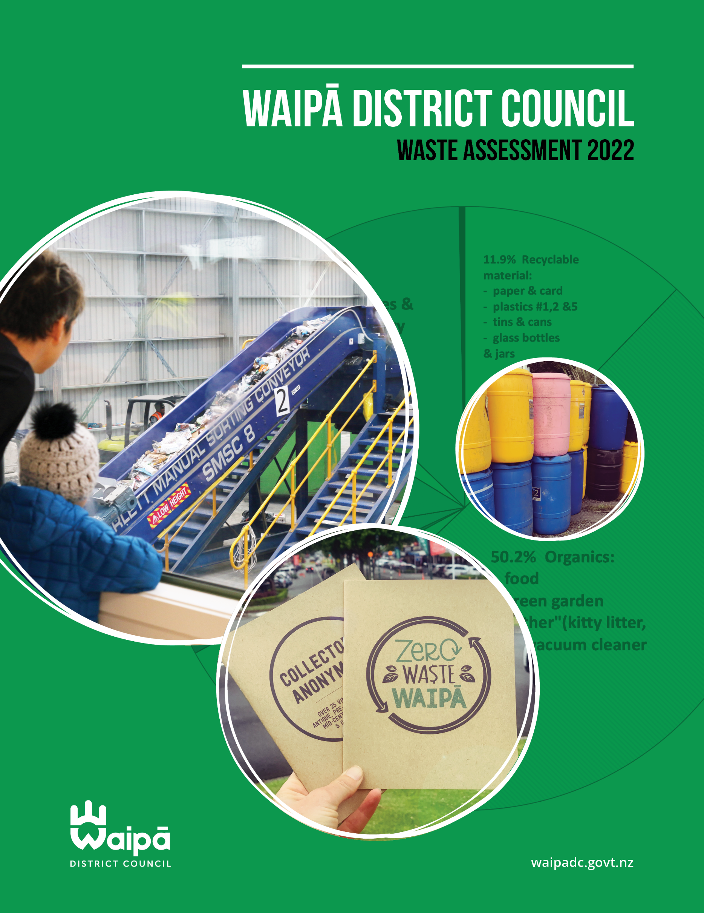

Contents

1.0 Introduction 5

Background 5

Purpose of this Waste Assessment 6

Scope 7

General data limitations, completeness and assumptions 7

Waipā District 7

2.0 Summary of waste services available in the Waipā District 8

Council contracted services 8

Other Waipā District Council programmes and services 8

Private services 8

Rubbish 8

Non serviced or community led services 9

Electronic waste (e-waste) services 9

Giving more life to items 9

Rural recycling 9

Hazardous waste 9

3.0 Waste infrastructure 10

3.1 Landfills 10

Closed Landfills 11

Clean Fill Facilities 11

3.2 Transfer Stations 11

3.3 Material recovery facilities. 11

3.4 Resource Recovery Centre 12

3.4 Green waste composting 12

4.0 Waste data 12

4.1 Waste disposed of to land 12

4.2 Kerbside recycling volumes and composition 14

4.3 Composition data and diversion potential from kerbside rubbish collection 15

4.4 Rural Waste Management 16

5.0 Review of the 2017 Waste Management and Minimisation Plan 17

6.0 Future demand 20

6.1 International considerations and treaties 20

6.2 Central Government policy levers 21

6.3 Population Growth 29

6.4 Economic Activity 30

6.5 Changes in lifestyle and consumption 31

6.6 Circular economy societal trends 31

6.7 Construction and demolition waste 32

6.8 Recycling Markets 32

6.9 Contract opportunities 33

6.10 Waste management during a crisis 34

6.11 Event waste 36

7.0 Gap Analysis 37

7.1 Additional gaps not previously discussed: 37

7.1.1 Medical waste 37

7.1.2 E-Waste 37

7.1.3 Data from non-Council controlled wastes is sparse 38

7.1.4 Illegal dumping is increasing 38

7.1.5 Domestic rubbish collection is not available in some areas 39

7.1.6 Transfer station services are not available in some areas 39

7.1.7 40

7.2 Gap analysis summary 40

Diversion potential 40

Policy changes 41

Infrastructure 41

Service provision 41

8.0 Statement of options 41

Table 9. Diversion options for organic waste 42

Table 10. Diversion options for cconstruction and demolition waste 43

Table 11. Reduce contamination from recycling service 44

Table 12. Policy, administrative and advocacy options 45

Table 13. Infrastructure Options 47

Table 14. Rubbish provision options 48

9.0 The Council’s intended role 50

Statutory Obligations 50

10.0 Statement of proposals 51

Statement of Extent 51

9.1.1 Statement of Protection of Public Health 51

9.1.2 Effective and Efficient Waste Management and Minimisation 51

11.0 Appendices 52

11.1 Appendix 1. Review of waste minimisation programme. 52

11.2 Appendix 2. Other council waste service offerings and cost. 59

11.3 Appendix 3: Consultation with Medical Officer of Health 63

# Introduction

## Background

The Waste Minimisation Act 2008 (the Act) requires all local councils to produce a Waste Minimisation and Management Plan (the Plan), which should be reviewed every six years. Waipā District Council’s current Waste Management and Minimisation Plan needs to be updated and in place by late 2023 in order to be compliant with the Act and remain eligible for funding from the waste levy. The waste levy funding that Council receives funds the Waste Minimisation Officer’s role and supporting operational budget which delivers on actions from the Waste Management and Minimisation Plan.

Section 50 of the Act requires all Territorial Authorities to prepare a Waste Assessment before reviewing their Waste Management and Minimisation Plan, while Section 51 dictates the contents of the Waste Assessment. This Waste Assessment informs the Waste Management and Minimisation Plan review process and will also provide feedback on progress on waste generation and diversion across the district as well as looking at future needs and opportunities.

When developing the last Plan in 2017, Council wanted to take a longer-term view of waste management and minimisation activities and developed the Waipā Waste Strategy to guide three consecutive Plans. The Waipā Waste Strategy sets out the overall goals and a strategic framework for managing waste in Waipā over the next 18 years. Each Waste Management and Minimisation Plan will detail the activities to be undertaken over the six years of each Waste Management and Minimisation Plan, in order to achieve the Waipā Waste Strategy goals. Where appropriate, activities to achieve the goals of the Waipā Waste Strategy will also be carried forward into Councils Long Term and Annual Plans to ensure the resourcing is available to achieve the goals and objectives in both the Plan and the Waipā Waste Strategy. This Waste Assessment is to inform the second of the three Waste Management and Minimisation Plans covered in the Waipā Waste Strategy.

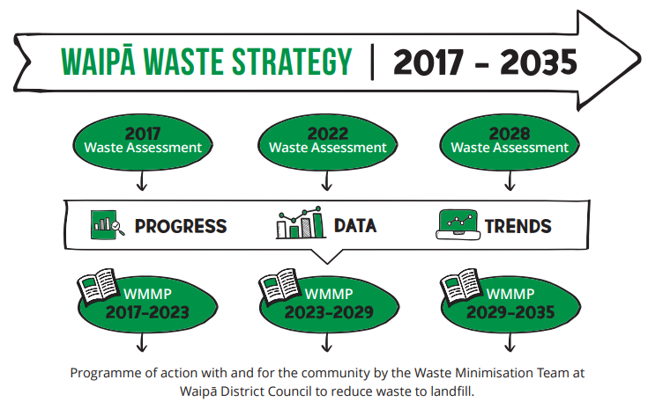

## Purpose of this Waste Assessment

The primary purpose of the assessment is to provide a focus on how Council can progress waste management and minimisation in an informed and effective manner. It should provide the information necessary to identify the key issues and priority actions to be included in a draft Waste Management and Minimisation Plan.

This waste assessment has been undertaken with reference to the ‘Waste Assessments and Waste Management and Minimisation Planning: A Guide for Territorial Authorities’ prepared by The Ministry and section 51 of the Act, which outlines that a waste assessment must include:

* A description of the collection, recycling, recovery, treatment, and disposal services provided within the territorial authority’s District
* A forecast of future demands
* A statement of options
* A statement of the territorial authority’s intended role in meeting the forecast demands
* A statement of the territorial authority’s proposals for meeting the forecast demands (including infrastructure), and
* A statement about the extent to which the proposals will protect public health, and promote effective and efficient waste management and minimisation.

## Scope

Under the Act, the Waste Assessment must go beyond those waste and material streams managed directly by the Council and include an assessment of current commercial and industrial waste streams, a forecast of future demand, consideration of options to meet forecast demand and determine Council’s intended role in meeting that demand.

Waipā District Council, like all Councils, has a responsibility to plan for all waste generated in the district when considering waste infrastructure and services. However, due to a lack of information available from waste operators and industries on waste types and volumes, effective and accurate planning is not always possible.

This plan was written from the end of 2021 until April 2022. As the policy space is fast moving at this time, some documents may have been released that were in consultation phase at the time of writing.

## General data limitations, completeness and assumptions

This document was written between July 2021 and December 2021 using information gathered from a variety of sources. The data is from 1 July 2020 to 30 June 2021 which was relatively normal in regards to COVID-19 with only Level One and Two restrictions in place in the Waikato region. While every effort has been made to achieve a reasonable degree of accuracy in this assessment, it should be noted that there have been limitations related to data availability.

The information obtained in this waste assessment is appropriate when giving regard to:

* the significance of the information.
* the costs of, and difficulty in, obtaining the information.
* the extent of the Council’s resources; and
* the possibility that the Council may be directed under the Health Act 1956 to provide the services referred to in that Act.

## Waipā District

The Waipā District is a landlocked territorial district in the Waikato Region, south of Hamilton and is home to approximately 57,000 residents principally in the towns of Cambridge, Te Awamutu and Kihikihi, but with a significant rural population as well. Waipā is a high-growth district with strong commuter links with Hamilton. Population growth is occurring principally in Waipā’s urban areas, but there has also been recent growth in rural villages. As of November 2021, there are 22,270 rateable properties in Waipā. Covering more than 1447km² and including some of New Zealand's most fertile land and fresh water, dairy farming is the largest sector of the Waipā economy, contributing $267million in 2020, equating to 9.2% of the district’s economy. For more information about the district [check Councils website](https://www.waipadc.govt.nz/your-waipa/about-waipa).

# Summary of waste services available in the Waipā District

## Council contracted services

Council provides each dwelling with two recycling wheelie bins. A 240L mixed recycling wheelie bin that accepts clean tins, cans, plastics #1,2 & 5 and paper/card. This is collected every two weeks. Glass (bottles and jars only) is collected in a 140L wheelie bin monthly.

Litterbin servicing, street sweeping, and illegal dumping clean up are funded partly through a general charge applied to all rates bills.

There is a $26,700 (as of December 2021) targeted rate to support the Envirowaste transfer station in Cambridge being open to the public on a part time basis.

## Other Waipā District Council programmes and services

Council delivers a waste minimisation education programme, which results in over 2,000 face-to-face (in person and live online) engagements. You can see a summary of deliverables in section 11.1.

## Private services

The Waste Minimisation and Management Bylaw 2018 gives Council a measure of control over the handling/transporting and collection of waste in the district. This bylaw includes (not definitive list):

* Responsibilities for residents and waste operators
* Licensing of waste operators
* Requirements for waste operators to collect and submit data
* Controls on collection, transport and disposal of waste
* Nuisance and litter
* Offences and enforcement.

### Rubbish

Domestic:  
Household rubbish kerbside collection is not a council rated service. Private waste companies offer services to the community ranging from 60L pre-paid bags to 120L or 240L wheelie bins. During the solid waste audit, a brief survey was undertaken on the rubbish collection choice of the community. While the sample size was small, the survey indicated domestic waste services chosen by Waipā households are:

* 77% of households used pre-paid bags
* 18% of households used 120-litre wheelie bins
* 5% of households used 240-litre wheelie bins.

Commercial/industrial:  
Commercial properties are not eligible nor charged rates for the council recycling wheelie bin service. Business and industrial customers don’t have a standard waste profile, like households do. They have a wider variety of waste types (from highly hazardous to basic office waste) and waste and recycling volumes range a lot more, meaning bespoke servicing suits the needs of each business better. Several companies offer services to the commercial/business sector in Waipā for both rubbish and recycling.

## Non serviced or community led services

### Electronic waste (e-waste) services

In 2018 an e-waste collection event was held by Council and the Te Awamutu Community Board, resulting in 19 tonnes of e-waste collected in four hours. In addition, a local social enterprise called Waipā Urban Miners is now operating regular collection events for e-waste in both Te Awamutu and Cambridge. Collected e-waste is responsibly recycled or re-used/sold. The start-up costs were funded by the Waipā District Council Waste Minimisation Community Fund and the Cambridge Discretionary Fund. Electronic waste is one of the first six products that the Government is enacting regulated product stewardship for. For more information see section 6.2.5.

### Giving more life to items

There is a thriving second-hand, op-shop, antiques and collectables scene in Waipā with over 25 stores and markets giving items a longer life in active use.

### Rural recycling

Waste companies are increasingly providing tailored waste services for the rural sector, increasing recycling volumes since the last waste assessment. In addition, two main providers operate voluntary product stewardship schemes for local producers and growers:

* [Agrecovery](https://agrecovery.co.nz/) provides a nationwide programme for the recovery of unwanted and expired agricultural chemicals. As well as plastic containers, drums and intermediate bulk containers (ICB’s 1x1m2 containers for transporting liquids) from agrichemical, animal health and dairy hygiene uses.
* [Plasback](https://plasback.co.nz/) predominately collects bailage wrap.

The Ministry for the Environment (The Ministry) has made all the material collected by these two current schemes part of the regulated product stewardship scheme for rural plastics (for more information see section 6.2.5). The regulated product stewardship scheme will expand the range of items collected, gathers costs from manufactures to fund the collection and recycling or safe disposal of these materials which will be great for the local farmers and growers.

### Hazardous waste

This comprises both liquid and solid wastes from both commercial and household sources. Hazardous waste in general requires further treatment before conventional disposal methods can be used. Most disposal goes to either landfill or through the trade waste system (regulated and licensed disposal through the wastewater system). Some of these treatments result in trans-media effects, with liquid wastes being disposed of as solids after treatment. A small proportion of hazardous wastes are ‘intractable’ and require exporting for treatment.

The Council does not have permanent facilities for the collection or disposal of hazardous materials requiring treatment, these are usually housed at transfer stations or landfills. Due to the size of the townships in the district it is unlikely the commercial sector will step into this space, and it would be inefficient for Waipā to fund a site alone. With the above-mentioned regulated product stewardship schemes funding through the scheme will likely assist transfer stations to play a more active role in the handling of hazardous rural liquid wastes.

Household hazardous waste is only a very small proportion of kerbside rubbish (less than one percent) yet it is of significant risk to the environment and requires special handling. Council and the Waikato Regional Council are planning a household hazardous waste collection in mid-2022, with further collections likely, if successful.

# Waste infrastructure

Waipā District Council owns no waste assets, transfer stations or machinery.

## 3.1 Landfills

There are no Class 1 municipal landfills in Waipā district. However, there are two landfill disposal options within 100 km. A high proportion of refuse is transported from Waipā District to landfills at Tirohia (owned by Waste Management) and Hampton Park (owned by Envirowaste), based mostly on these companies market share of domestic and commercial collections locally. While these facilities are some distance from Waipā District, the material is bulked and consolidated for transport at nearby transfer station facilities both in the district and close by.

The nearest landfills to the district are listed below:

|  |  |  |  |  |
| --- | --- | --- | --- | --- |
| **Location** | **Name/Operator** | **Type** | **Key Services/Waste Streams** | **Capacity & Estimated Operational Life** |
| Tirohia, Paeroa | **Waste Management NZ Ltd** | Municipal Landfill | Non-hazardous residential, commercial and industrial solid waste, including special wastes. Sludges with less than 20% solid by weight are prohibited. | Consented to approx. 2035. Undergoing consenting processes to increase capacity to 2032-35, otherwise will close by approx. 2024. |
| Hampton Downs, North Waikato | **Envirowaste Services Ltd** | Municipal Landfill | Non-hazardous residential, commercial and industrial solid waste, including special wastes. Sludges with less than 20% solid by weight are prohibited. | Consented to 2030. |

**Table 1 – Local landfill facilities**

Rotorua Lakes District Council and Taupo District Council each own a landfill for waste from within the council’s own District only.

Modern landfills are expensive to design, build, operate, consent and maintain. There is trend away from councils owning and operating their own landfill/s, to councils using larger privately run landfills nearby. There does not appear to be a need for a council owned landfill within the district. If longer term planning is to be required to ensure the region as a whole has suitable landfill access in the 20–50-year term, this is more suitable as a joint council or a private initiative.

### Closed Landfills

Council owns four closed landfill sites; these are located in Cambridge, Te Awamutu, Kihikihi and Pirongia. The sites have all been capped and are used for non-invasive activities. Council holds Resource Consents for the discharge of leachate into the ground and for the discharge of contaminants into the air and consents require monitoring six monthly or quarterly.

### Clean Fill Facilities

The WasteMINZ [Technical Guidelines for Disposal](https://www.wasteminz.org.nz/pubs/technical-guidelines-for-disposal-to-land-april-2016/) to Land define clean fills and clean fill material as follows “Clean fill - a class 5 landfill. Accepts only clean fill material, including clean virgin excavated natural materials such as clay, soil and rock that are free of any contaminates. When discharged to the environment, clean fill material will not have a detectable effect relative to the background.” There are several consented clean fill sites in the Waipā District, mostly associated with quarrying work and are not open to the public. As the Ministry will soon be seeking to apply the levy to all classes of landfill they are currently investigating all possible fill sites in NZ.

## 3.2 Transfer Stations

Refuse Transfer Stations (RTS) provide a service for larger items that cannot be disposed of in kerbside rubbish collection and for residents that can’t or choose not to make the journey to an out-of-region landfill. Waste can be dropped off at these sites by the public and commercial collectors after paying a gate fee, and the waste is subsequently compacted before being transported to a landfill.

Waipā District Council is the only council in the Waikato Region that does not own a Refuse Transfer Station.

There are two privately owned transfer stations in Waipā District, one in Cambridge and one in Te Awamutu. These stations act as central bulking points for rubbish, where recyclable and a few selected waste streams of reusable materials are separated out from waste prior to transfer to landfill, for example, scrap metal, recyclables and green waste which is transferred to composting facilities.

## 3.3 Material recovery facilities.

At a Materials Recovery Facility, dry recyclables/commodities are sorted and bulked for transport to recycling facilities outside the region for processing.

In Waipā, household mixed recycling is currently sorted locally at a 2020 built Materials Recovery Facility, owned and operated by Metallic Sweeping. It is referred to publicly as the Recycling Sorting Centre. Mixed recycling is hand sorted into single material stream bales with a low contamination rate. Each separate material is then on-sold for re-processing in New Zealand where possible, or into the international market as needed. Glass is bulked at the same site and then transported to OI in Auckland for use in making new glass bottles and jars for the NZ food and beverage industry.

In general, the collection and processing of dry recyclables is a mature market, with limited opportunity for expansion. Services for construction and demolition (treated wood, MDF, concrete etc) is currently very limited and this does restrict any positive changes to current waste management systems on building sites due to cost to access diversion services for these materials.

## 3.4 Resource Recovery Centre

During the 2021 consultation on the Long Term Plan the community supported investment in Waipā’s very first resource recovery centre. As opposed to a Transfer Station (as discussed in 3.2 and 7.1.5) whose primary task is to bulk rubbish for transport to landfill, the resource recovery centre model is about reuse. It’s about getting as many items back into reuse through upcycling, reuse, repurposing, sales, composting or recycling.

The preferred option during the Long Term Plan consultation was to partner with a community organisation, charitable group or iwi partner through a contract to develop a resource recovery centre that would service the District. The preference was for Council to find an existing building on an industrial or commercial site and remodel it to suit the purpose for resource recovery. The location is to be determined and planning and market assessment are in development. This centre is planned to open within the time frame of the next Waste Minimisation and Management Plan which is 2023-2029.

## 3.4 Green waste composting

There is one large composter in district, Revital, operating in the outskirts of Leamington.  They operate open windrow composting for green waste, where the composting happens naturally in large rows of green waste material over several months. Virtually all their compost is sold to farmers and horticulturalists.  They receive green waste from Council’s urban leaf fall collection, households, but also larger amounts from some of the garden and green waste collection businesses and transfer stations. Revital can accept delivery of certified compostable packaging though acceptance is on a case by case basis as each facility can accept different quantities and different types of packaging and there is a cost associated with that.

# Waste data

## 4.1 Waste disposed of to land

Waste disposal to land has declined in the Waipā district since 2015/16, primarily due to improvements in the management of sludge from the wastewater plant and increased use of recycling and recovery services by the rural sector, which has reduced the tonnage of waste disposed of to land.

|  |  |  |  |  |  |  |
| --- | --- | --- | --- | --- | --- | --- |
| **Waste disposed of to land** | **Tonnes (rounded)** | | **% of total** | | **Tonnes/ capita/ annum[1]** | |
|  | **2015 - 2016** | **2020-2021** | **2015 - 2016** | **2020-2021** | **2015 - 2016** | **2020-2021** |
| **General waste to landfill** | 22,000 | 27,000 | 25.3% | 37.4% | 0.5 | **0.5** |
| **Sludge - currently stockpiled** | 6,000 | 1,500 | 6.9% | 2.1% | 0.1 | **0.003** |
| **Farm waste disposed of on-site** | 59,000 | 43,600 | 67.8% | 60.5% | 1.3 | **0.7** |
| **TOTAL** | **87,000** | **72,100** | **100%** | **100%** | **1.9** | **1.2** |

**Table 2 – Waste disposed of to land**Note: 2015-2016 population: 46,668 (census 2013); 2020-2021 population: 58,294 (draft NIDEA 2021 high growth scenario)

General waste to landfill for the district has increased from approximately 22,000 tonnes per annum in 2015/16, to 27,000 tonnes per annum 2020-/21. However, on a per population basis, this remains unchanged at 0.5 tonnes per capita (500kgs of waste per person). Nationally, waste per capita is approximately 0.7 tonnes (740kg of waste per person). An unchanged per population assessment of waste to landfill can be viewed positively as per capita waste to landfill volumes have increased year on year for more than a decade in all areas of New Zealand. The plateau in per capita rates may be due to a combination of factors, including waste minimisation measures implemented by council as well as improvement in the amount and quality of data collected on waste streams for this waste assessment compared to previous assessments.

|  |  |  |  |  |  |  |
| --- | --- | --- | --- | --- | --- | --- |
| **Material** | **Tonnes (rounded)** | | | **Tonnes/ capita/ annum[2]** | | |
|  | **2009-2010** | **2015-2016** | **2020-2021** | **2009-2010** | **2015-2016** | **2020-2021** |
| **General waste to landfill** | 12,000 | 22,000 | 27,000 | 0.3 | 0.5 | 0.5 |
| **Recyclables (kerbside + RTS)** | 4,100 | 4,400 | 5,200 | 0.1 | 0.1 | 0.1 |

**Table 3 – Landfill waste and recycling volumes. 2021: Tonnes / capita / annum**   
Note: 2015-2016 population: 46,668 (census 2013); 2020-2021 population: 58,294 (draft NIDEA 2021 high growth scenario)

## 4.2 Kerbside recycling volumes and composition

A 2020 solid waste audit of fortnightly yellow mixed recycling wheelie bins indicated an average weight of materials of 6.17 kg per bin including 0.75 kg of contamination (material which should not be included in recycling). The largest proportion by weight is paper, this is expected as paper and cardboard weigh a lot more than aluminium or plastic. See Table 4 below for recycling proportions and volumes.

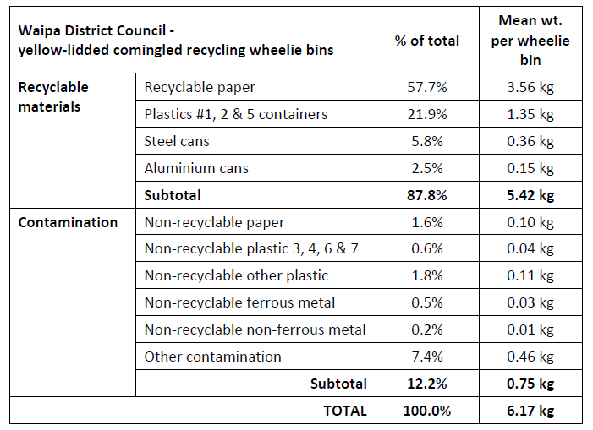

**Table 4 – Proportions and weights of recycling and contamination materials**

|  |  |  |
| --- | --- | --- |
| Kerbside recycling | 2015-2016 | 2020-2021 |
| **Kerbside recycling (kg)** | 3,411,000 | **1,774,610** |
| **Population** | 46,668 | **58,294** |
| **Kg/capita/annum** | 73kg | **30kg** |

**Table 5 – 2021: Per Capita Kerbside Recycling – Kg/Capita/Annum**   
Note: 2015-2016 population: 46,668 (census 2013); 2020-2021 population: 58,294 (draft NIDEA 2021 high growth scenario)

Table 5 shows a significant reduction in the volume of recycled materials collected occurred between 2015/16 and 2020/1. On a per kilogram/capita/annum basis, recyclable volumes reduced from 73kg to 30kg, a 41% decrease.

Several factors may have influenced this reduction in recycling volume including:

**The impact of global changes to the recyclables market.**China and other countries who commonly received recyclables from New Zealand changed their acceptance policies, leading to significant changes to what materials would be accepted and ceasing the acceptance of certain types of recyclable materials in kerbside collections. Mixed plastic bales are now also illegal under the Basel Convention. Due to these changes Council stopped collecting plastics #3, #4, #6 and #7.

**Low recycling commodity market.**  
To meet the new, lower contamination thresholds there has been a larger focus on cleanliness of recycling across our sort line to maintain the quality of single stream materials sent to market, resulting in some materials being termed as contamination that might have been sorted in the past.

**The impact of nationwide and localised Covid-19 health measures.**   
Due to H&S risk recycling was unable to be hand sorted for six weeks during the level 4 & 3 lockdowns in 2020/21, resulting in all material during that time being sent to landfill (an estimated 11.5% of the annual total).

**Improvement in the amount and quality of data collected.**Recycling data in the 2015 Waste Assessment was based on pro-rata estimates of recycling truck volumes. The past contractor collected recycling from multiple locations, Waipā and other districts and Waipā tonnages were estimated proportionally based on the number of trucks from Waipā that emptied off and what the output of the sort line for all collection areas was. Councils current contractor has a sorting centre in the district and recycling volumes can now be measured (as opposed to estimated) resulting in more accurate data.

**Collection methodologies.**   
At the time of the last Waste Assessment, Waipā had a crate based system where paper was collected tied, bagged or boxed on the side of the crate, open to the weather. In the 2015/16 waste audit, the weight of paper was high (compared to NZ wide data and Waipā’s second audit in 2020) as the paper was out in the weather and wet paper is heavy. The new wheelie bin system keeps paper and card dry as there is a lid, leading to a reduction in paper weight in the most recent audit. There is a noticeable trend for people to consume their news online these days, resulting in less newspapers in recycling.

## **4.3 Composition data and diversion potential from kerbside rubbish collection**

Waste audits have identified that 5.7% of kerbside rubbish is recyclable paper and 3.2% is recyclable plastics (#1,2, & 5). Recyclable tins, cans and glass bottles and jars made up another 3% of all household rubbish in bags. Altogether 12% of kerbside rubbish could have been recycled in the council rated kerbside recycling service. This is a reduction compared to the 2017 audit (14.9%), likely due to the new wheelie bin recycling service.

50.2% of all rubbish was organic material and it is the biggest area with potential to increase diversion from landfill. The majority of organics is food (72% of all organics in the domestic rubbish was food), 16% was green garden waste and the remainder was ‘other organics’ like kitty litter, animal bedding and poop, hair, dust etc. (11.5%). A kerbside food waste collection has potential for a large volume of diversion alongside home composting and community composting hubs.

Based on the waste audit, the total diversion potential for Waipā kerbside waste collections (e.g., for recyclables that incorrectly ended up in the rubbish and organics being composted) is 62% (by weight) of household rubbish. For the full report of the solid waste audit, please start at page 59 of [the Service Delivery Report of Feb 2021](https://www.waipadc.govt.nz/repository/libraries/id:26zgz4o7s1cxbyk7hfo7/hierarchy/agendasandminutes/Agendas%20February%202021/Service%20Delivery%20Public%20Agenda%20-%2016%20February%202021.pdf).

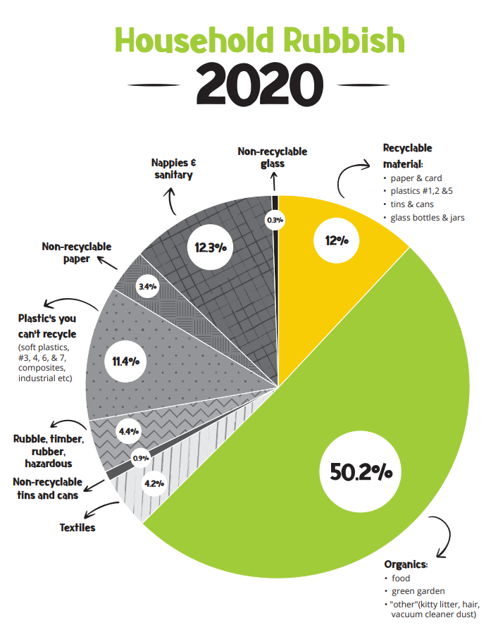

**Graph 1 – Potential diversion from household rubbish 2020**

## 4.4 Rural Waste Management

While research on rural waste is limited, a 2014 report estimates inorganic material (animal vet waste, plastics, concrete, scrap metal, tyres, timber, hoses, used machinery etc) makes up 85% of on farm waste, with a further 10% organic and animal waste.

Further support for recycling agricultural chemicals (including containers), and silage wrap, may reduce outdated practices such as on-site disposal (burying in farm dumps), bulk stockpiling or burning of waste. The government is working on regulated product stewardship scheme to support this sector (see section 6.2.5).

# Review of the 2017 Waste Management and Minimisation Plan

As required by the Act, council completed a review of the last waste management and minimisation plan, which was adopted in 2017.

The key issues identified in the preparation of the last Waste Management and Minimisation Plan were:

**Not enough information.**Council doesn’t have access to data and information about waste in the district because most waste services are provided by private companies.

**Low recycling rates.**  
While kerbside recycling has been good, recycling rates are static and commercial recycling rates are low. Council can improve how much we recycle and reuse waste.

**Infrastructure and services.**  
There is potential to work with other councils to share the costs of infrastructure development or on common services like litter education.

**Farm waste.**  
With a large area of rural land use Waipā has a high volume of rural waste. While some services are available to farms, there is an opportunity to help more.

**Community capacity.**  
Community groups are interested in establishing a resource recovery centre, but there is a low level of operational knowledge which would allow the introduction of community partnerships for waste minimisation.

**Hazardous waste.**  
There are limited opportunities for household hazardous waste disposal.

**Independent assessment of progress**

These issues were progressed in the 2017-23 Waste Management and Minimisation Plan and the progress and actions are outlined in Appendix 1. An independent waste contractor was asked to review the progress against the last Waste Management and Minimisation Plan and give feedback on progress, as covered in table 6 below.

|  |
| --- |
| **GOAL 1. Reduced waste and increased resource recovery** |
| **A1. Continue existing kerbside recycling.** Waipā District Council met expectations and targets for Activity 1 related to kerbside recycling.  Review Comments:  Waipā District Council has undertaken substantial activity around kerbside recycling, increasing service  levels and engagement with the community. However, due to international export acceptability criteria, this has not translated into an increase in recycling rates – which have decreased from 73kg per person in 2016 - 2017; to 30kg per person in 2020 – 2021.  The 2019 – 2020 international changes in materials able to be exported resulted in Waipā ceasing the  collection of plastics 3, 4, 6, & 7, reducing total collected. Many councils similarly reduced service levels, due to this international phenomenon. Despite not achieving the target of a 25% increase in Resource recovery via kerbside recycling, this review considers Waipā District Council met its targets for Activity 1 (overall, taking into consideration challenges that were out of its hands). |
| **A2. Continue providing litter bins and collecting illegal dumping.** Waipā District Council has met expectations for Activity 2 related to providing litter bins and collecting illegal dumping.  Review Comments:  Tonnages of litter and street sweepings remained approximately the same from 2016-2017 to 2020-2021. |
| **A3. Advocate for increased producer responsibility.** Waipā District Council has met expectations for Activity 3 related to advocating for product stewardship. |
| **A4. Investigate options to support businesses to reduce waste and increase recycling.** Waipā District Council has met expectations for Activity 4, with ongoing waste minimisation support  and education for businesses in the Waipā district.  Review Comments:  The review notes it is not possible to estimate whether Waipā District Council is meeting its  target of a 25% increase in resource recovery by 2023 as there is no baseline of waste created by participating  businesses. The review also notes that the international changes to what materials are able to be exported for recycling is likely to have impacted this target. |
| **GOAL 2. Collect waste information for informed decision making.** |
| **A5. Update bylaw.** Waipā District Council has met expectations for Activity 5, with the adoption of the Waipā District  Council Solid Waste Management and Minimisation Bylaw 2018. |
| **A6. Introduce a licencing system for operators.** Waipā District Council has met expectations for Activity 6 relating to a licensing system for waste operators.  Review Comments:  While the target of a licensing system by 2020 has not been met by the date specified, this review considers  the extension of the scope of the target to include sub-regional licencing justifies the extension to the  timeframe: and that Waipā District Council is making substantial effort to achieve licencing. |
| **A7. Complete compositional waste audit every three years.** Waipā District Council has met targets and expectations for Activity 7 relating to a compositional waste audit.  Review Comments:  This review notes that best practise guidance has changed since 2017. Current recommendations are  for a single audit prior to a Waste Assessment (6 yearly). |
| **A8. Establish a Community Waste Forum.** Waipā Waste Minimisation Officer has met expectations for Activity 8 relating to a Community Waste Forum.  Review Comments:  This review commends Waipā District Council for their efforts to support and engage the Waipā community around waste minimisation. |
| **A9. Joint working, partnerships, co-operate with other councils** Waipā District Council has met expectations for Activity 9 relating to partnerships & co-operation.  Review Comments:  This review commends Waipā District Council for their efforts to partner with other organisations, businesses and the community. It is clear that, despite its size, Waipā district have been influential at a regional level in supporting and progressing waste minimisation activities. |
| **A10. Continue to support waste education including working with farms and businesses to achieve waste reduction.** Waipā District Council has met expectations for Activity 10 relating to a supporting waste education.  Review Comments:  This Review notes the 2017 Waste Management and Minimisation Plan set out specific expectations for community education around businesses and farms. Goal 1 Activity 4 included reference to educational support for businesses, and this review considers those activities show the expectations relating to business education have been met.  This review notes Waipā District Council partnered With Agrecovery to deliver a recycling event.  However, it is unclear whether that constitutes sufficient education to count as fully meeting  expectations for rural education set out under this activity.  Recommendation:  Waipā District Council consider further activities focused on the farming community to better meet  expectations set out under Activity 10. |
| **A11. Continue the Waste Minimisation Community Fund.**  Waipā District Council has met expectations for Activity 11 relating to a funding grant. |
| **A12. Promote composting and other ways to reduce food waste.** Waipā District Council has met expectations for Activity 12 relating to composting and reducing food  waste.  Review Comments:  This review commends Waipā District Council on efforts to encourage composting and a reduction in food waste. It can also be noted that these activities will support the Waipā district community in relation to climate adaptation resilience. |
| **GOAL 4. Effective waste services and facilities** |
| **A13. Investigate and develop resilient access to waste infrastructure and processing facilities within the Waikato region that minimise the impact of external market fluctuations and provide sustainable waste services.** Waipā District Council has met expectations for Activity 13 relating to waste infrastructure.  Review Comments:  This review notes the challenges related to this work since 2017. These challenges have included:  • Ongoing changes in government policy and legislation  • Substantial, repeated international changes in materials able to be exported  • An international pandemic impacting the development of infrastructure |
| **A14. Resource Recovery facilities are investigated and developed, pending feasibility studies.** Waipā District Council has not met expectations for Activity 14 relating to resource recovery facilities.  Review Comments:  This review notes the challenges related to this work since 2017, including changes to government policy and legislation, and an international pandemic impacting development of infrastructure. |
| **A15. Improved access to hazardous waste disposal.** Waipā District Council has not met expectations for Activity 15 relating to hazardous waste.  Review Comments:  This review acknowledges that this is not a priority waste stream for Waipā District Council, and notes  that hazardous waste is a Regional Council responsibility.  Recommendation:  Waipā District Council monitor the situation, while recognising that this activity may not have been  necessary to include in the 2017 Waste Management and Minimisation Plan (particularly given the activities to promote agricultural hazardous  waste collections). |

**Table 6 – Review of the 2017-21 Waste Management and Minimisation Plans actions**

**Compliance with Ministry Requirements**  
  
In June 2021 staff from the Ministry visited Waipā to audit the spend of the waste levy funding Council receives. Comments from the compliance report were strongly positive:  
*“Overall, WDC evidenced a strong level of compliance with their obligations under the Act. Levy*

*expenditure for the last reported financial year (2019/2020) was in line with legislative requirements*

*and the processes undertaken to plan for and spend levy funds were comprehensive and extremely*

*well documented. No areas of non-compliance were identified and WDC are not recommended for any follow up action or audits outside future regular audit programmes.”*

# Future demand

A wide range of factors can affect future demand for waste and resource recovery services and infrastructure, and these can vary over time. Key factors which may affect Waipā ’s waste minimisation and management outcomes are outlined below.

### 6.1 International considerations and treaties

New Zealand is party to the following key international agreements that relate to waste and recycling:

1. [Montreal Protocol](https://www.unep.org/ozonaction/who-we-are/about-montreal-protocol) – to protect the ozone layer by phasing out the production of numerous substances
2. [Basel Convention](https://environment.govt.nz/what-government-is-doing/international-action/basel-convention/) – to reduce the movement of hazardous wastes between nations
3. [Stockholm Convention](https://environment.govt.nz/what-government-is-doing/international-action/stockholm-convention-persistent-organic-pollutants/) – to eliminate or restrict the production and use of persistent organic pollutants
4. [Waigani Convention](https://environment.govt.nz/what-government-is-doing/international-action/the-waigani-convention/) – bans export of hazardous or radioactive waste to Pacific Islands Forum countries

While they do not immediately impact on Waipā’s waste flows, it is worth noting the potential impact of international activities on New Zealand’s waste industry. For example, much of New Zealand’s recycling has historically been exported to Asia, particularly China. Since 2018 China has ceased accepting the worlds recycled materials which have had far reaching impacts on the recycling industry, which have been felt locally specifically around finding markets for the recycling materials and commodity pricing. Both of which affect the cost of the Councils recycling contract for ratepayers.

Global pandemics, international conflict and impacts of climate change have the potential to disrupt recycling supply chains. As New Zealand has few processing facilities for kerbside recyclables, NZ is more vulnerable should export markets be disrupted.

### Central Government policy levers

Key policies that may result in legislation about and influence consumer behaviour and demand for rubbish and recycling services include the NZ Waste Strategy, The Waste Act, The Emissions Reduction Plan and the Emissions Trading Scheme.

Council is also required to comply with the requirements of Section 17A of the Local Government Amendment Act 2014. “*A local authority must review the cost-effectiveness of current arrangements for meeting the needs of communities within its district or region for good-quality local infrastructure, local public services, and performance of regulatory functions.”*

The government is currently considering several significant legislative changes as to how New Zealand manages its waste, which will impact Waipā’s waste services and the services provided by the private sector. Depending on the number of changes and the significance of any changes, this is likely to impact Waipā District Council resourcing for both staff time and budget. Areas of policy change are outlined below.

#### 6.2.1 [Waste Levy](https://environment.govt.nz/what-government-is-doing/areas-of-work/waste/waste-disposal-levy/overview/)

The Ministry, on 1 July 2021, increased the landfill levy and intends to apply it to more classes of landfill (classes 1-4) progressively from 2023. The levy was historically only charged at landfills that take household waste, accounting for around only 40 percent of total waste sent to landfill, that will change from 2023. See table 7 below for the expanded levy timeframe. The additional revenue from the waste levy is ringfenced for waste minimisation activities, including infrastructure.

The levy is currently $20 per tonne of waste, which is very low by international standards. Increasing the levy will better reflect the full environmental, social and economic costs of disposal of waste to land and help make diversion services more financially viable. The levy increase is expected to help transition New Zealand to a circular economy and create employment.

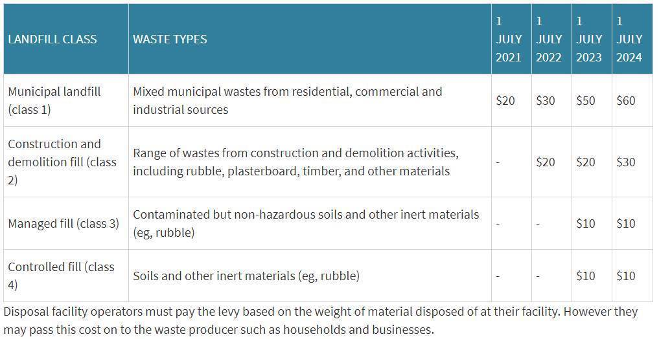

**Table 7 – The Ministry waste levy increase and expansion.**

The impact of the levy increase will largely take place during the term of the 2023-2020 Waste Management and Minimisation Plan, impacting waste tonnages and movement in the district in an unpredictable manner as well as affecting the amount of waste levy council receives.

#### 6.2.2 [The NZ Waste Strategy, Te kawe I te haepapa para – Taking responsibility for our waste](https://consult.environment.govt.nz/waste/taking-responsibility-for-our-waste/)

The Ministry is currently consulting on a draft NZ Waste Strategy which indicates a strong turn towards the circular economy model and the waste hierarchy. The NZ Waste Strategy outlines the proposed vision and aspirations for a low-waste Aotearoa, and how the Government plans to get there. The NZ Waste Strategy will guide and direct New Zealand’s collective journey towards a circular economy. The strategy sets our course to 2050 with three broad stages as seen below.  
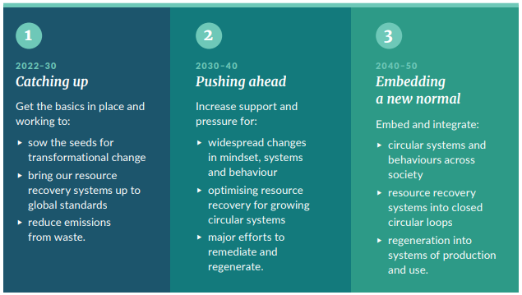  
Targets are very ambitious, including a 60-70% reduction in household waste to landfill.  
  
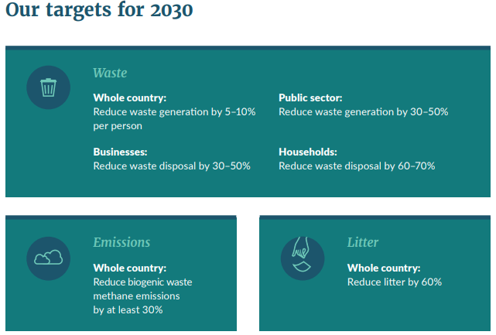

The scale and ambition indicated in this draft strategy will undoubtably impact the Waipā community, local businesses and council.

#### 6.2.3 [Emissions Reduction Plan](https://environment.govt.nz/assets/publications/Emissions-reduction-plan-discussion-document.pdf)

Following the final advice of the independent Climate Change Commission (the Commission) conversations have been underway across Government about how Ministers and agencies can support emissions reductions in their portfolios – and that has resulted in the first emissions reduction plan, due to be. This plan will set out the policies and strategies Aotearoa New Zealand will take to meet the first emissions budget, helping to transition to a low-emissions future in a way that is achievable and affordable. There were seven “key sectors” in the plan and one was waste and one was building and construction. So there will be a strong focus from the Government to reduce carbon emissions from these areas. The below are examples of ideas considered that relate most to waste.

**Potential and proposed measures for the waste sector:**

Options to cut waste disposal emissions broadly fall into three categories – reducing organic waste material, reducing organic waste disposal to landfill, and reducing emissions from organic waste if it ends up in landfill.

**Reducing food waste**

Reducing the amount of food waste has environmental, economic, and social benefits. Every dollar invested in businesses that reduce food scraps gains a $14 return.

**Reducing waste from construction and demolition**

Buildings are a significant contributor to waste emissions. There is potential to shift the sector towards a circular economy, designing out waste when buildings are designed and made, with options for reusing and re-purposing materials when they reach the end of their life. The Building for Climate Change programme will consider this.

**Identifying options for treated wood (reduction, diversion and disposal)**

Wood waste is a mixture of products from the construction industry. When identifiable, untreated timber can more easily be diverted for reuse (native timber in particular) or as a feedstock for boiler fuel.

**Reducing organic waste disposal to landfill**

**Food waste and green waste collection**

Organic resources that cannot be used as food can be processed into nutrients and bioenergy. These materials are commonly recovered internationally. Both the feedstock and the resulting products are valuable resources in a circular bioeconomy, with significant potential to reduce our reliance on fossil fuel fertilisers and energy.

Although some household food and green waste is being diverted already, there is substantial scope for better recovery. Many households send food and green waste to landfill via kerbside rubbish collections.

**Businesses to separate food and green waste**

Food and green waste emit significant amounts of methane in landfills. A driver for change will be promoting the separation, diversion and collection of these materials, and investing in processing facilities.

**Better paper and cardboard recycling**

As for other types of organic waste, paper and cardboard produce methane when disposed of in landfills and make up a sizable proportion of waste in municipal landfills. Clean, separated paper and cardboard are very recyclable. Recyclability decreases when they have been mixed with other materials (such as in commingled recycling bins) or are heavily contaminated with food or other waste.

**Transfer stations to prioritise recovery alongside new and expanded materials recovery facilities (MRFs)**

In addition to source separation, the requirement to separate material streams can apply to transfer stations, where trailers and skip bins of waste are split into material streams to maximise recovery.

**The Building for Climate Change programme will also consider:**

* **Circular economy package:** A potential suite of initiatives and incentives to reduce construction waste and increase reuse, repurposing and recycling of materials.
* This could include scaling up existing building-related circular economy initiatives and providing guidance and information to help reduce construction waste across a building’s lifecycle, from construction to demolition.
* Elements of this package could build on the Ministry for the Environment’s Waste Minimisation Fund, with a specific focus on rolling out or scaling up building-related circular economy initiatives. For example, funding the expansion of existing local programmes through to supporting major businesses to trial or champion demonstrated programmes.
* It could also include providing guidance and information about ways for designers, builders, procurers and others to reduce construction waste across a building’s lifecycle, from construction to demolition. The proposed behaviour change programme could also include a circular economy focus, driving both consumer and sector activity.

#### 6.2.4 [National Infrastructure Strategy](https://www.tewaihanga.govt.nz/strategy/state-of-plays/resource-recovery-and-waste/)

In 2021 the Ministry released a national stocktake of waste infrastructure and worked with key stakeholders to discuss options to meet identified gaps. Alongside this was a more detailed investigation into fibre (paper and cardboard) which set out an implementation roadmap to improve the diversion of fibre from landfill. The short fall is large: just for recycling infrastructure the report states “*it has been estimated that between $2.1 - 2.6 billion of additional capital investment is needed, along with an additional $0.9 billion in operational funding over the next 10 years.”*

These research projects provide councils with a framework for future infrastructure provision with some certainty on investment and delivery.

The Ministry also made $124 million investment in onshore recycling infrastructure. This is a non-contestable fund and although not publicised; decisions have already been made where the money will be invested. $10–12 million in annual funding through the Ministry’s Waste Minimisation Fund is planned to take early steps to lift the performance of New Zealand’s resource recovery and waste system, and move toward a low-waste, more circular economy.

#### 6.2.5 [Waste Data](https://environment.govt.nz/what-government-is-doing/cabinet-papers/improving-the-availability-of-waste-data-additional-proposals-with-proposed-redactions-marked-and-proactive-release-coversheet/)

Along with changes to Waste Levy, legislative changes for waste data reporting will also be implemented over the next few years. This will require waste operators, refuse transfer stations, landfills and councils to submit data on waste streams, sources, types and amounts. It is expected that this reporting will utilise the National Waste Data Framework.

#### 6.2.6 [Regulated Product Stewardship](https://environment.govt.nz/what-government-is-doing/areas-of-work/waste/product-stewardship/regulated-product-stewardship/)

The Act allows for regulated product stewardship that would make producers responsible for specified problematic products at the end of life and ensure the costs of proper waste management are paid by producers, retailers and consumers, not communities, councils and the environment. In July 2020 the Ministry declared six priority products to have regulated product stewardship:

1. Tyres and large batteries (currently consulting on proposed regulations)
2. Electrical and electronic products [e-waste] (accreditation applications and consultation on regulations for these schemes are anticipated from the second half of 2022)
3. Farm plastics (accreditation applications and consultation on regulations for these schemes are anticipated from the second half of 2022)
4. Refrigerants and other synthetic greenhouse gases (scheme co-design has been completed)
5. Agrichemicals and their containers (scheme co-design has been completed)
6. Single-use plastic packaging (scheme co-design has not started)

Once operational these schemes will have a significant impact on the Waipā community. Schemes 1, 2, & 6 will have daily or at least annual touch points for most people who shop and have a car. For example, some food or beverage packaging might change to a readily recyclable option, and consumers can return e-waste to the store or collection point with the cost to responsibly recycle already paid at purchase. The farm plastics scheme will result in a good outcome for Waipā’s rural community, allowing them to access a scheme to do the right thing with rural wastes where the cost is covered and collected at manufacture stage. Waipā Councils role is to assist local operators to become involved and advocate for access for the community.

#### 6.2.7 [Reviewing and amalgamating the Waste Minimisation Act 2008 and the Litter Act 1979](https://environment.govt.nz/what-government-is-doing/areas-of-work/waste/waste-legislation-review/)

The Ministry is also proposing new and more comprehensive legislation on waste to replace the Waste Minimisation Act 2008 and the Litter Act 1979.

#### 6.2.8 Container Return Scheme

The Ministry is (as of April 2022) consulting on a container return scheme. A container return scheme is a resource recovery scheme that encourages people to return beverage containers for recycling in exchange for a refundable deposit. When someone buys a drink, they pay a refundable deposit on the normal price of the drink. When the empty beverage container is returned to a container return scheme collection point, the person gets that deposit refunded. It is proposed that deposit is 20 cents per container. Based on the proposed design outlined in the consultation document, it expected that implementation of the NZ container return scheme will increase recycling rates to 85–90 per cent, which will significantly reduce litter. Most Australian states have a scheme in operation and there are at least 35 other container return schemes operating globally.

A consideration important for council will be how container return scheme will affect existing kerbside collections. Kerbside collections would not disappear, but a scheme is expected to affect the types and amounts of recyclables collected, but income lost through some householders holding back recycling to redeem the deposit themselves will be offset by council contractors also redeeming the deposit on all applicable containers that do come through kerbside collection.

On 26 April 2022 Waipā District Council supported the proposed container return scheme with caveats as outlined in the [feedback](https://www.waipadc.govt.nz/repository/libraries/id:26zgz4o7s1cxbyk7hfo7/hierarchy/agendasandminutes/Agendas%202022/April%202022/Council%20Public%20Agenda%20-%2026%20April%202022.pdf) to the Ministry on their consultation.

More information is available on the Ministry [website.](https://environment.govt.nz/what-government-is-doing/areas-of-work/waste/container-return-scheme-reducing-waste-landfill/)

#### 6.2.9 Standardising recycling

The Ministry is (as of April 2022) consulting on national standardisation of what items can and can’t be recycled across NZ; as the quality of recycling materials is more important than ever. Council’s kerbside recycling contract currently closely aligns with the Ministry’s proposed standard items to collect. This definitive list was generated with recycling re-processors first to ensure what Councils collect, is what recycling re-processors can on-sell and make into something new (to be recycled). There are only small changes/clarification and education on what’s accepted locally needed to align fully with the proposed national standardisation and these are:

* Plastic – nothing smaller than a single yoghurt container from a 6-pack or dip container
* All lids (plastic or metal) off and put in rubbish bins
* No aluminium foil or single use cooking trays
* No paper/card smaller than a sticky note paper (e.g., Post-it notes, sticky labels or paper tape)
* No shredded paper

On 26 April 2022 Waipā District Council supported standardisation of recycling with caveats and concern around targets, cost burden to rate payers and more as outlined in the [feedback](https://www.waipadc.govt.nz/repository/libraries/id:26zgz4o7s1cxbyk7hfo7/hierarchy/agendasandminutes/Agendas%202022/April%202022/Council%20Public%20Agenda%20-%2026%20April%202022.pdf) to the Ministry on their consultation.

More information is available on the Ministry [website.](https://environment.govt.nz/publications/improvements-to-household-kerbside-recycling-snapshot-of-the-consultation/)

#### 6.2.10 Separation of business food waste

The Ministry is (as of April 2022) consulting on a proposal to require all businesses to collect food waste separately from other waste materials to reduce climate emissions from organics in landfill and recycle nutrients back into our soil. The Ministry proposes a staged roll out dependant on access (within 150 km) to existing composting facilities. The expectation set out in the consultation is that by 2030 Waipā businesses will be separating food waste.

On 26 April 2022 Waipā District Council supported standardisation of recycling with caveats and concern around the definition of “business” as outlined in the [feedback](https://www.waipadc.govt.nz/repository/libraries/id:26zgz4o7s1cxbyk7hfo7/hierarchy/agendasandminutes/Agendas%202022/April%202022/Council%20Public%20Agenda%20-%2026%20April%202022.pdf) to the Ministry on their consultation.

More information is available on the Ministry [website](https://environment.govt.nz/what-you-can-do/stories/transforming-recycling-business-food-scraps/).

#### 6.2.11 Compostable products

In early 2022 the Ministry released a position statement on compostable products as part of their National Plastics Action Plan and it describes the Ministry’s position (covered below) on where compostable products could play a role in a circular economy. Global awareness of how plastic impacts the environment has increased in recent years. At the same time, consumers and companies are identifying ways to reduce their environmental impact, including by choosing alternatives to single-use plastic packaging and packaging made from fossil fuels. In New Zealand, where we have a relatively high per capita use of plastics compared to other OECD countries, manufacturers are exploring alternatives such as biodegradable plastics, degradable plastics, compostable plastics, and biobased plastics. Some of these materials function similarly to conventional plastic; however, these different products have different disposal pathways, which can cause confusion for the public and manufacturers.

When considering the role compostable products can play in a circular economy, it is worth noting that compostable products provide no nutrient value to the compost. This means the only potential value of compostable products lies in their ability to help divert food waste from landfill to compost or in removing a potential contaminant in a food waste collection bin.

Compostable products present challenges.

* Compostable products often end up in landfill due to confusion about how to dispose of them and a lack of collections and processing infrastructure (for example, in the United Kingdom [research](https://publications.parliament.uk/pa/cm201719/cmselect/cmenvaud/657/657.pdf) has found that only 1 in 400 coffee cups actually get composted).
* Consumers often incorrectly believe that compostable products can break down when littered; however, when littered or lost to waterways or the sea, compostable products are contaminants. They are not designed to degrade in these environments.
* Compostable products contaminate recycling bins and our domestic soft plastic collection scheme as they look similar to conventional plastic; however, they are not recyclable.
* We have limited sorting and processing infrastructure in New Zealand to properly manage compostable packaging, in particular for the majority of our compostable products that require the high temperatures of ‘industrial’ composting systems to degrade.

For now, the Ministry consider compostable products could have a role in a circular economy in New Zealand:

* in closed-loop settings where they help divert food to compost
* where plastic polymers would usually contaminate the compost or soil (e.g., produce labels).

It is proposed that Council applies this cautionary approach to compostable products in any policy or funding decisions also.  
  
More information is available on the Ministry [website.](https://environment.govt.nz/publications/compostable-products-ministry-for-the-environment-position-statement/)

#### 6.2.12 Waste to Energy

Waipā District Council received a consent for a large scale incinerator in early 2022, which is a type of waste to energy . This proposal is published on the Councils [website.](https://www.waipadc.govt.nz/our-services/planning-and-resource-consents/consent-applications-of-interest) Waste to energy refers to a family of technologies that process waste material to generate energy.

In early 2022 the Government released a guide on waste to energy (covered below) which gives an overview of the different types of waste to energy technologies and aspects of the New Zealand context that may be relevant when considering waste to energy proposals.

Waste to energy technologies have attracted interest around the world because they have the potential to solve several pressing problems at once:

* how to dispose of increasing amounts of waste being generated in modern societies, given limited space in landfills and the greenhouse gas emissions of poor disposal techniques
* shortages in power generation and a desire to move away from fossil fuels.

However, waste to energy technologies vary greatly, reflecting the wide range of materials that can be processed. It is important to assess individual proposals carefully to understand their particular strengths and weaknesses within the New Zealand context.

Waste to energy that uses renewable feedstock (the “waste” input and amount needed to make a site financially viable) is likely to be preferable, because it aligns better with environmental and circular economy values. It also supports the Government’s target of 90 per cent of electricity from renewable sources by 2025. Renewable feedstock will comprise organic or biogenic material. Waste to energy technology using this type of feedstock **will produce renewable energy**. Examples of organic or biogenic material currently used as feedstock for renewable energy include:

* wood waste from pulp and paper mills and wood processors
* black liquor, a by-product derived from wood
* biomass or other organic solid wastes in landfills or from sewage, which can be used to produce biogas through anaerobic digestion
* agricultural waste (e.g., tallow), which can be used to produce liquid biofuels.

If the waste feedstock is derived from fossil fuels, like plastic waste, this is **not** a renewable material **and the plant will not produce renewable energy**. Mixed solid waste is typically a mixed waste stream, consisting of both waste derived from fossil fuels and waste derived from biogenic and organic material.

Waste to energy technologies may produce by-products and residues from the combustion processes in the form of slag, combustion gases, char waste and different kinds of ash. The by-products and residues will vary with the feedstock and technology and need to be handled safely in perpetuity.

A key output of waste to energy is the energy, but a question that the Ministry proposes when considering waste to energy is: Does New Zealand need more renewable sources of energy? New Zealand has a high level of renewable electricity generation compared to some other countries. However, non-renewable energy sources still make a significant contribution to total energy consumption. For example, more than 60 per cent of New Zealand’s total energy needs are met by fossil fuels, in particular in the transport sector (20 per cent of emissions) and industrial sector (8 per cent of emissions).

New Zealand is a long narrow country, with a small population spread out across it. We do not have the very large population centres of some other countries. Our geography for transporting large quantities of feedstock can also be challenging, given our hills, rivers and coastlines. We also experience natural hazards like earthquakes, floods, eruptions, cyclones and droughts. Due to New Zealand’s remoteness, if access to feedstock were to change and importing waste was required, this would likely be costly and impractical. Deciding where to locate a waste to energy plant safely, and ensuring it would have access to sufficient feedstock, might provide quite a different challenge in New Zealand than elsewhere.

Another question is whether creating a system that requires waste to be supplied in bulk for feedstock is consistent with the Ministry’s and Councils broader environmental goals, particularly in relation to waste and energy. The Ministry has a rapidly developing work waste and resource efficiency programme. Its aim is to create a low-waste and low-emissions economy with a world-leading and resilient resource recovery sector and a low-emissions energy system. And Council’s Waste Strategy charts a course to *“Embracing a circular economy”* which is fleshed out to read “*our communities and businesses are actively engaged in developing services and infrastructure to avoid and reduce waste, increase repair and reuse; and increase resource recovery. Communities expect, and businesses deliver, products that are part of a whole-of-life management system*”.

Currently there is a lot of action in the policy space for waste in New Zealand; as covered in sections 6.2.1 the waste levy, 6.2.2 The NZ Waste Strategy, 6.2.3 Emissions Reductions Plan, amongst others. Included in these documents are targets to reduce municipal waste by 60-70% in less than 10 years, to start mandatory product stewardship schemes, to reduce building and construction waste to landfill, all of these (and many more actions) would greatly change the accessibility to feedstock for a large Waste to energy proposal.

More information is available on the Ministry [website.](https://environment.govt.nz/publications/waste-to-energy-guide-for-new-zealand/)

### 6.3 Population Growth

Recent population growth in Waipā has been higher than anticipated and has exceeded earlier Demographic and Economic Analysis (NIDEA) 2013 and NIDEA 2016 population projections. At the 2018 census, Waipā District had a population count of 53,241 people. Using the high growth NIDEA scenario in 2021 the population is estimated at 58,294.

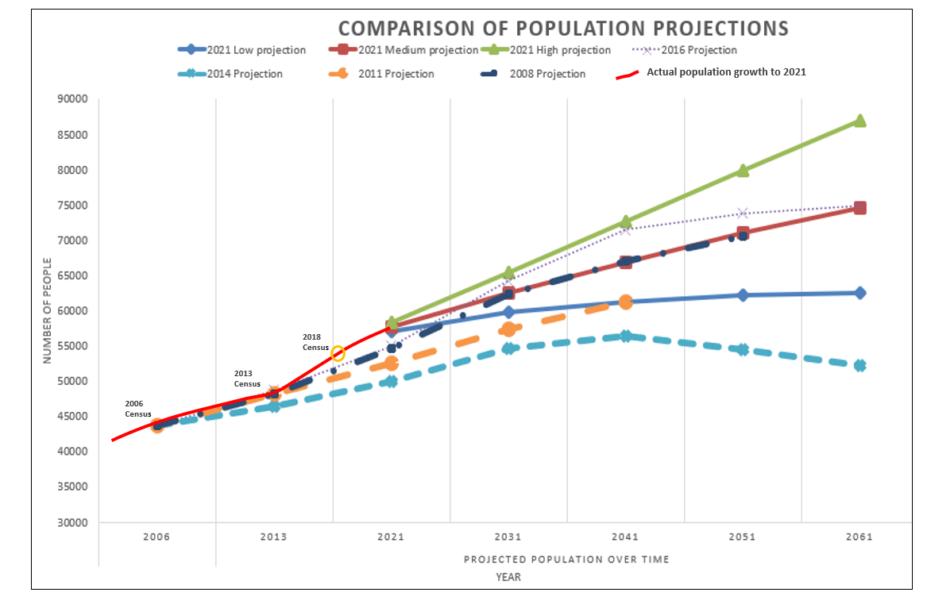  
Graph 2. NIDEA 2021 population projections for Waipā District compared with earlier projections  
  
More than 70%[3] of the district’s population growth is concentrated in the district’s three urban areas of Cambridge, Te Awamutu and Kihikihi. The 2017 Waipā 2050 Growth Strategy identifies a number of urban development ‘growth cells’ around each of these towns to accommodate anticipated future population growth over the next 30 years.

Council’s kerbside recycling services has increased by approximately 300 households per year since the last Waste Assessment and is expected to increase by approximately 3,000 over the next 10 years. Waipā is a high growth area, all additional businesses and residential properties will contribute to increases in waste generated within the district.

### 6.4 Economic Activity

Economic growth is correlated with waste production. Higher levels of economic activity lead to greater production and consumption of goods and this, in turn, leads to higher quantities of waste. Waipā has enjoyed a sustained period of economic growth over the last eleven years which, like population growth, is expected to continue.

### 6.5 Changes in lifestyle and consumption

Community expectations relating to recycling, waste minimisation and waste management are increasing. It is challenging for Council to meet these expectations when recycling markets are not available or financially viable (or acceptable to ratepayers). Likewise, new minimisation initiatives may not be viable locally.

Consumption habits affect the generation rates of waste and recyclable material. For example, while there has been a national trend related to the decline in newsprint, the ongoing growth in electronic devices will ensure that e-waste continues to be a growing waste stream, with many individuals and most households now having multiple personal electronic devices like mobile phones, tablets and computers.

Retail purchasing habits are also changing and impacting the waste that is created. Increasingly more retail transactions are occurring online which is seeing a corresponding rise in packaging waste which accelerated due to COVID-19. The NZ Post [Full Download Report](https://thefulldownload.co.nz/sites/default/files/2021-05/NZPost_TheFullDownload_2021.pdf) on 2020 (the most recent year available) reported a 25% growth in online spending, 71% of all online spend is with local retailers (possible higher due to well publicised delays on international boat freighting due to COVID-19), 306,000 people shopped online for the first time and New Zealanders are shopping online more often, on average 22.92 times a year, up 8.6% from 2019. And this is a trend likely to continue, NZ Post states “online makes up only 11% of all Kiwi shopping spend. In the UK and US, online penetration is well over 20%. This leaves plenty of room to grow in New Zealand”.

Growing access to international retail websites (e.g. Ali Express, Amazon etc) also means that there is an expanding range of products that can be ordered quickly, easily and often for a very low price. It gets packaged up for international freight and ends up on our doorsteps. This easier access to retail products and cheaper prices means the volume of purchases being made is increasing while also creating a more disposable approach to the items being bought. It’s common for these lower purchase prices to translate to lower quality products with a shorter lifespan and due to being bought online, returning for repair is very unlikely. Product marketing means existing goods are often discarded in favour of the latest trend.

If something breaks, it’s often easier to replace it rather than have it repaired, and planned obsolescence is also common in electronic items like laptops, mobile phones, and TVs – meaning they may need to be replaced to remain functional. All of this leads to more goods being bought and eventually need to be recycled (where possible) or landfilled.

### 6.6 Circular economy societal trends

Consumer demand for waste reduction is seeing a small; but growing number of circular products, systems and solutions coming to market.Council’s own [Waipā Zero Waste Guide](https://www.waipadc.govt.nz/repository/libraries/id:26zgz4o7s1cxbyk7hfo7/hierarchy/our-services/rubbish-and-recycling/waste-minimisation/zero%20waste/WDC%20ZWW%20full%20booklet%202022.pdf) released in 2021, listed over 30 different local businesses and organisations in the region that were offering products or services in the waste reduction and circular economy space. One local example is [Kaipaki Dairies](https://www.kaipakidairies.co.nz/) who provide zero-waste milk for consumers in a swap-a-bottle and a tap system in supermarkets and specialty stores as well as a refillable 18Lkeg system for cafes.

There are also various groups, movements and organisations now focusing on the circular economy across Aotearoa New Zealand. These include those focusing on circular economy strategy like [Circularity](https://www.circularity.co.nz/) and community based resource recovery like [Localised](https://www.localised.nz/). There is also increasing engagement around reusable packaging and service ware e.g. reusable coffee cups and takeaway containers. Individual use of reusables is becoming more mainstream, product solutions for borrowing reusables are [emerging](https://www.reusabowl.nz/), and there are more and more organisations advocating and working for systems change for reusables including [Reuse Aotearoa](https://reuseaotearoa.org.nz/) and [TakeAway Throwaways](https://takeawaythrowaways.nz/).  
  
There is also a growing [repair movement](https://www.facebook.com/RepairCafeNZ/) which is seeing a growth in community repair cafes (where household goods can be fixed and repair skills learnt) and also advocacy for ‘right to repair’ legislation.

### 6.7 Construction and demolition waste

Construction is a major sector of the Waipā economy, and all new urban, business and industrial development contributes to construction waste. [Waikato Regional Council estimates](https://waikatoregion.govt.nz/services/regional-services/waste-hazardous-substances-and-contaminated-sites/construction-and-demolition-waste/) that 27.5% of all waste sent to landfills (by weight) is construction and demolition waste.

There is an opportunity to introduce waste minimisation initiatives during both the construction and operational stages. Waste minimisation should therefore be an important consideration in all development planning processes. Yet there needs to be ease of access to collections, services, markets and infrastructure to support diversion of these sometimes tricky waste streams found in construction and demolition. And the scale of these solutions often need regional or (probably) government level support.

With housing intensification occurring there is a lot of house demolition occurring in the district. It is not easy to capture data on this via the building process as it is a permitted activity. There are opportunities to follow Kainga Ora’s policy lead of house removal and re-siting as the preferred option, then de-construction (site allowing) before demolition is considered. Strong groundwork has been done to test if de-construction is financially viable against demolition and landfilling, and it is. Several larger councils have a staff member specifically for construction and demolition waste as it is such a significant part of the waste volume.

### 6.8 Recycling Markets

Historically, China has been the largest buyer of recyclables and previously purchased over 50 percent of all the world’s supply. In July of 2017, China announced restrictions on the import of 24 types of material into the country. The new policy has created issues in the recycling industry with new strict standards for mixed paper and mixed plastic. These materials can still theoretically be imported into China, but they are required to have very low levels of contamination – 0.5 percent. Most kerbside recycling systems in NZ are not able to produce levels of contamination this low (around 2-4 percent is typical). So, while China has not directly banned imports of recyclable materials, their policies have drastically reduced demand in the biggest market. The reduction in demand has seen prices for these and related grades of material fall dramatically. Sellers of these commodities have sought other markets, but there is not sufficient capacity in the plants outside of China to process all the materials. The overall result is stockpiling, with some councils no longer able to collect the recyclables they used to, including Waipā District Council - where collections of plastics grades # 3, 4, 6 and 7 ceased in April 2020.

New Zealand can process approximately half of the paper and cardboard that is collected domestically but only a small proportion of the plastic, with no significant local processing of plastic grades #3, 4, 6 and 7. Like most other countries with kerbside recycling, New Zealand previously sent a lot of its mixed paper and mixed plastic bales to China. Paper and plastics are usually two of the most valuable kerbside commodities for recyclers in terms of revenue. Paper because it makes up the largest amount by weight (40-50 percent) and plastic because some grades can command high prices. The large decrease in price, and the difficulty in finding markets for these grades of material is therefore severely affecting the economic viability of local collections.

Due to the excess of recyclable materials, quality is now more important. Receivers have lower levels of acceptable contamination and to maintain acceptance, our tolerance for contamination is now much lower also. Which has increased the amount of contamination in the recycling.

### 6.9 Contract opportunities

Council’s existing recycling contract ends in 2026, providing an opportunity to assess additional services such as a kerbside food waste collection or introducing council provided rubbish services. The Council is also required to comply with Section 17A of the Local Government Amendment Act 2014, which has specific criteria for a service review.

*17A Delivery of services*

*“(1) A local authority must review the cost-effectiveness of current arrangements for meeting the needs of communities within its district or region for good-quality local infrastructure, local public services, and performance of regulatory functions.”*

Food and organic material in landfills have been strongly targeted as an area for improvement by both the draft NZ Waste Strategy, the draft Emissions Reduction Plan, and most recently in the [Transforming Recycling](https://environment.govt.nz/news/transforming-recycling/) consultation that proposes all councils provide a kerbside food collection and all businesses will need to separate food waste.

Providing a rates funded rubbish service could create benefits to the community on a scale that warrants further investigation. Possible benefits are:

* Through offering a rates funded rubbish service, there is consistent services across the district.
* Having a rates funded rubbish service (compared to pre-paid bags) would likely reduce contamination in the recycling wheelie bin so decreasing costs on that contract.
* Having a contracted rubbish service can provide more stability and certainty about cost as most are controlled through a well written contract. Rubbish collection is simpler than recycling and there are no issues like contamination rates and commodity prices that can impact rising contract costs. Gate fees for waste are the main element that will fluctuate, but that cost is predictable due to the Ministry signalling changes to the cost of the waste levy 5 years in advance and measures being able to be applied to predict emissions trading prices.
* Council contacts are written to cover the costs of the service, not to generate profit as private business does. Indications show there could be more cost-efficient service offering per household for waste services if rubbish were a council contract.
* Increased customer service on kerbside rubbish services.
* Reducing truck movements in neighbourhoods.
* Data and information. Overtime we will be able to know much more about our community’s rubbish volumes, set out rates etc and use this information to educate, create supporting services and track progress.
* Elements of user pays can be worked into a rates funded service (e.g., set number of bags are provided each year, more can be bought if needed, or “pay as you throw” tags added to wheelie bins).

However, introducing a council rubbish service may adversely impact businesses who currently provide private rubbish services (a few are locally owned and operated and a few are large multi-nationals). Further investigation and public consultation into possible cost efficiencies, benefits and impacts would be required before any changes were initiated.

Based off preliminary research into current waste service costs of seven other similar sized councils (Western Bay, Marlborough, Waimakariri, Tasman, Invercargill, Gisborne and Selwyn) it is likely that council could develop a contract package (rubbish and recycling) that would result in most households paying less than they are now with the council recycling service and market led rubbish service.

For more information and some comparisons with other councils see section 11.2 - Appendix 2.

### 6.10 Waste management during a crisis

**Natural disasters**

Natural disasters are significant waste generators as seen after the Christchurch earthquakes and flooding in Whakatāne. In response to these disasters a Disaster Waste Management Planning Guide has been developed, led by Environment Canterbury, Bay of Plenty and Waikato Regional Council. Further work led by Waikato Regional Council has allowed waste volume predictions to be loaded into GIS so that web based tool can be used to model, predict and then plan what do to with waste in the case of a natural disaster.   
   
As Waipā does not own any transfer stations, landfills or have large areas of unused industrial land, the district may face challenges in clearing disaster related waste in a timely fashion or coping with large waste volumes if a natural disaster were to occur in the district. Further disaster planning is prudent.

**Health Pandemic**

This Waste Assessment is being written at the time of the COVID-19 pandemic which has provided an example of how quickly waste trends can change. Single use personal protection equipment (masks specifically) have become common as litter on our streets, parks and carparks and added to volumes of waste. Lockdown “clean ups” resulted in large peaks for already stressed essential workers to deal with, along with increased contamination in the recycling service. And this does not cover waste generated within the health system. This has resulted in significant short-term effects on the district’s waste and recycling services some of which are outlined below:

* Refuse transfer stations closed for months at a time and only accepting ‘essential services’ waste
* Kerbside recycling services suspended during COVID-19 levels 4 & 3 for approximately 1,000 households that need manual handling of their wheelie bins
* During COVID-19 levels 4 & 3 mixed recycling cannot be hand sorted so is landfilled
* During COVID-19 lockdowns the waste industry in NZ has seen trends of an **increase** in kerbside collected refuse volumes and single use PPE gear and **decreases** in construction waste, green waste diversion, tourism and private waste operator related waste
* Online shopping has increased with restrictions on shops being open. Online shopping generates large volumes of cardboard boxes (because everything is shipped) which bulks out the recycling trucks making it hard to complete their route, takes up space in the drop off area at the MRF resulting in longer shifts for the team to keep the pile manageable and further weakens the market due to oversupply.

The effects of the pandemic on waste and recycling volumes may continue for a number of months. It is possible that there will be a drop in commercial waste for a longer period as some companies may not be able to continue operating due to financial difficulties during the ‘lock-down’ period. Likewise, the District has and will continue to experience a drop in tourist and event related waste volumes.

One other effect of the COVID-19 pandemic has been a significant increase in the number of people working from home. This has resulted in a decrease in office/commercial waste and an increase in household waste. Working from home is becoming more common and the related effects on waste streams are expected to continue long term.

Community and food resilience  
There are links from emergency response preparedness and community and food resilience. One or two generations ago it was typical for urban households to grow food in the backyard. We are now increasingly reliant on supermarkets and other retail outlets for all of our food needs. With that change comes increased food packaging (all the way along the supply chain from pesticide containers, to shipping to shop packaging and advertising), carbon impacts, cost for consumers as well as a decrease in participation of growing and appreciation in the value of food. This disconnection to our food is also most likely increasing the amount of edible food that is wasted in our kitchens.

However, we are also now seeing a variety of initiatives and movements re-connecting communities with food and growing.

* Community food sharing is becoming more popular, as noted by Crop Swap events in Cambridge and six community food pantries/Sharing Shed’s operating across the district.
* There are at least two thriving community gardens, Cambridge Community in Vogel Street and also a maraa kai at the Maori Womens Welfare League in Kihikihi, both of whom regularly have food to give away to the community weekly for free, koha or some work weeding. A more recent addition are the Pop Up Edible Gardens in Cambridge with three successful sites engaging people in learning, growing and harvesting.
* Markets where growers sell directly to customers are going strong in Waipā with the Cambridge Farmers Market operating weekly year round as a plastic free market, and the seasonal Te Awamutu Produce Market mostly operating during daylight saving hours. And veg boxes made to order weekly from the Pironiga Community Garden are all good examples of Waipā’s local, low-no packaging, food scene.
* During the COVID-19 lockdowns in 2020 and 2021 there were shortages of seedlings and seeds nationwide as people looked to feel safer about their access to fresh food and as interest in gardening for pleasure grew.
* The [Garden to Table](https://gardentotable.org.nz/) programme in schools utilise older volunteers to share their gardening and cooking expertise with students as they grow, harvest, cook then eat their food. This is active at Paterangi, Karapiro, Cambridge, Hautapu and Wharepapa South schools. The Enviroschools programme supports students learning about and doing composting, worm farming and growing.
* The Christchurch City Council has launched an [impressive programme focused](https://ccc.govt.nz/environment/sustainability/edible-christchurch) on enhancing city and regional food systems through food resilience looking to create themselves as the “Edible Garden City” of the world.
* In other areas of New Zealand urban farms are becoming popular as a low carbon alternative to traditional farming methods, with small, underutilised spaces (inside and outside) used to grow a large amount of food for sale to local restaurants and communities. [Kelmana Garden](https://www.kelmarnagardens.nz/) in Grey Lynn, Auckland is perhaps one of the longest operating urban farms in New Zealand, run on council land, they now they have a market garden, a shop, do garden dinners, sell compost as well as raise sheep and have honey bees. Urban farms can provide a place for community to take green and/or food waste to be made into rich compost to grow more food, which reduces waste to landfill.

### 6.11 Event waste

Events can be large generators of single use waste, but offer the benefit of a restricted area and a method of communication (PSA, event collateral, website etc) to drive the correct behaviour. Some councils around NZ offer funding or deliver directly (via contractors) waste minimisation services at council owned venues and hosted events and at larger privately run events. Reuse is better than recycling, and that is seen in events too where event goers pay a deposit for a cup and that amount is redeemable if they return the cup at the end of the day/event to be washed and reused. There are also examples where the cup is of a higher quality and event goers keep it for the whole time and take it home. Free water taps are common at events, encouraging bringing your own bottle, which has waste minimisation and event goer health benefits. The Waste Minimisation Fund supported the installation of two such water refill stations on their event bank at Karāpiro Domain. Some events are pitched as zero waste, where anything you get within the event (a plate, food wrapper, a cup etc) is either compostable or recyclable, so anything event goers bring themselves that doesn’t fit those two criteria must be taken home with them.

Currently Waipā does not have the funding to support waste servicing at events. Supported through the Waste Minimisation Community Fund a pilot at Mystery Creek proved that you could host a large number of campers and feed them three meals a day on compostable tableware, transport 1.06 tonnes of food and compostables to Tuakau and get it composted.

The Waste Minimisation Team also has a set of five bin covers for smaller events, that indicate what wheelie bin is for recycling and rubbish. These are free to borrow, use and return for events held in Waipā.

# Gap Analysis

## 7.1 Additional gaps not previously discussed:

7.1.1 Medical waste  
The gap is typical household waste services do not suit many in-home medical care items for example:

* Hazardous waste (which can be sharps, such as needles, or non-sharps such as infectious waste or radioactive)
* Controlled waste (such as potentially infectious bodily fluids)
* Non-hazardous waste (which is general waste or recyclables).

At home, non-hazardous waste can generally be managed through usual general refuse and recycling services. However, the management of hazardous and controlled wastes at home can be difficult, and with the increasing prevalence of in-home medical care, this is becoming a more significant problem. There have been incidences of dialysis tubing with blood product contamination in Councils recycling. Ideally, in-home medical care would include provision for appropriate handling and disposal of medical wastes via the DHB.

While Council is not responsible for the provision of medical waste management services for either home-based care or medical facilities, it would be beneficial for Council to work proactively with DHBs and other medical service providers to ensure that appropriate services are being offered and put in place.

7.1.2 E-Waste  
The gap is that there is a lot of e-waste produced and not much is recycled. The Ministry is currently working on a national regulated product stewardship scheme for e-waste.

Waipā Urban Miners provide e-waste collection and recycling services and Council refer customers to them for this service. It is mostly cheaper to dispose of e-waste items through the transfer stations (to landfill) than it is to pay the ‘recycling fee’ at this time. However, that will change when the regulated scheme is in place and would allow a social enterprise like Waipā Urban Miners to participate in the scheme and get paid for what they collect, rather than the consumer paying them per item.

Commonly non-ethical e-waste recycling companies tend to cherry pick the more valuable items such as whiteware and mobile phones. As a result the more difficult or expensive items to responsibly recycle such as CRT TVs and domestic batteries will often still be sent to landfill.

### ***7.1.3*** Data from non-Council controlled wastes is sparse

The lack of information available on waste collected by parties other than the Council makes it difficult to build a full picture of waste in the District, therefore making it more difficult to accurately identify future demand and gaps in service. Holding better data on non-Council controlled waste would also help the Council to support the proposed national waste data framework. In the review of the NZ Waste Strategy led by the Ministry they are considering licencing operators nationally, or regionally, which would be beneficial for data collection, but also local council resourcing and in the [Transforming Recycling](https://environment.govt.nz/news/transforming-recycling/) consultation this covers a recommendation on compulsory reporting on household kerbside collections offered by the private sector. If neither of these central Government led interventions come to pass, Council will need to implement the provisions in Council’s bylaw for waste operator licencing and data collection, along with central government’s proposals for data collection, in order to get data from local companies who are not willing to provide it voluntarily.

### ***7.1.4*** Illegal dumping is increasing

COVID-19 appears to have had a negative impact on illegal dumping, with increased incidences occurring during 2020. Illegal dumping (larger items as opposed to litter) and rural littering is unsightly, causes concern to the local community where it occurs, can cause environment harm and costs council $152,182 on average over the last three years to clean up. The reasons why people do illegal dumping are complex, and often interrelated to societal issues of eviction/need to move in a short time frame, low income, lack of access/ease to access correct places (e.g. no car/trailer and/or tow bar).

|  |  |  |
| --- | --- | --- |
| Year | Breakdown of costs for illegal dumping  and rural litter picking. | Total cost of contract to clean up and dispose. |
| 2018-19 | Roadside Litter Pick Up $36,000  Illegal Dumping $60,000  Waste Disposal Costs $11,104 | $107,104 |
| 2019-20 | Roadside Litter Pick Up $96,000  Illegal Dumping $133,172  Waste Disposal Costs $15,588 | $244,760 |
| 2020-21 | Roadside Litter Pick Up $36,000  Illegal Dumping $60,000  Waste Disposal Costs $8,689 | $104,683 |

**Table 8. Cost to clean up incidences of illegal dumping and rural roadside littering.**

Illegal dumping of larger items is more costly and more hazardous as the items can contain anything and the large volume and weight increases disposal costs. The number of customer requests recorded by council for illegal dumping has been on the rise in the past three years. In 2018-19 there were 153 incidences, that rose to 347 illegal dumping pickups the following year and in 2020-21 it rose again to 495.

### ***7.1.5 Domestic*** rubbish collection is not available in some areas

Rubbish collection was privatized over 20 years ago and Council has no involvement in the provision of service. The majority of the district has access to different private kerbside rubbish services, a small number of rural areas do not have access to kerbside rubbish services. Overtime residents in these areas that are not serviced have established what became known as “drop off points” at intersections on the edge of the collection zone so trucks passing this point collected bags from these locations. Historically this worked well but more recently some of these sites have attracted up to 50 bags at a time with bags increasingly left several days prior to collection. This started to cause issues with vermin, odour, bags being ripped open causing litter. It also attracted fly-tipping of other refuse. A number of sites were near residential dwellings creating an issue for those residents and significant staff time is spent investigating complaints.

Council identified three sites that were of greatest significance and worked with the private rubbish collector in the area to stop collection at these “drop off points”. A mail drop was done to residents four weeks in advance of the change and large signs were erected on each of the sites. Once the collection ceased, compliance monitoring and enforcement was undertaken. The last of the three sites had its collection stopped on 1st June 2021, there have been no reports of bags at any of these sites in recent months.

In 2021 the main company collecting pre-paid rubbish bags reduced its service area, excluding some sparsely populated rural roads. As a result rural service levels have declined.

### ***7.1.6*** Transfer station services are not available in some areas

As discussed in 3.2 Council does not own any transfer stations. Waste Management operates a transfer station in Te Awamutu with bulk rubbish disposal as well as some diversion services (reuse shop, limited construction and demolition timber, bulk recycling, scrap metal and green waste) independent of council and with no subsidy.

In Cambridge, Envirowaste bought the transfer station land from Council pre 2003, built and operated the station with full public access when the Cambridge Landfill in Shelley Street closed. Later Envirowaste restricted public opening hours and operated the site more as a bulking depot for their own operations. To ensure the Cambridge transfer station remained open to the public, residents were consulted as part of the 2009- 19 ten year plan and were supportive of a targeted rate (to be applied to Leamington and Cambridge ratepayers) of a payment of $26,700 to Envirowaste to ensure the transfer station is open to the public for 24 hours per week.

In December 2021 the transfer station was closed for structural safety improvements including barrier protection on the top of the tip face, engineering measures to reduce the risk a car or trailer could back right off and improvements to safety for people as they exit vehicles to dump rubbish. And also, CCTV cameras to allow Envirowaste to follow up with people who illegally dump out of hours.  Envirowaste has estimated $150,000 to complete these works. To date these works have not been done and the station remains closed.

If the site re-opens, it is likely that gate fees and opening hours may change to meet operational needs, including to ensure the site is financially viable.  An increase in the council payment may be required to support full time opening hours. The subsidy has not been raised in 6 years. 

7.1.7 [Circular economy - Ōhanga āmiomio](https://environment.govt.nz/what-government-is-doing/areas-of-work/waste/ohanga-amiomio-circular-economy/)  
There are currently many missing opportunities for items to be in a circular economy due to reliance on a linear economy until recent times. Central government is currently leading NZ towards a circular economy, where “waste” from one product or system is a resource in another. A circular economy is an alternative to the traditional linear economy in which resources are kept in use for as long as possible, the maximum value is extracted from them whilst in use, then recover and regenerate products and materials at the end of each service life.

The current linear economy of take (from the natural environment), make (often a single use item), and dispose (in a landfill site) is not sustainable. A key element of the circular economy is to re-design products by engaging with the producers, manufacturers and retailers to take more responsibility for the end of life of their products or packaging; the current system leaves Councils and ratepayers trying to responsibly handle all “waste” at our cost.

For a circular economy to work there needs to be equitable access to Government-supported diversion infrastructure. For example, currently Auckland builders can send skips to construction and demolition diversion services which have been the recipient of several Waste Fund grants from MfE. In the Waikato there is no such access for construction and demolition diversion. Transporting waste for diversion is still cost prohibitive. Equitable access for all regions is therefore essential when developing infrastructure to support the circular economy.

There will be benefits to those businesses that adapt and align with the circular economy principals, so facilitating early adoption with local businesses will be beneficial to waste generation, reversing the impacts on climate change, long-term cost savings and job creation.

## 7.2 Gap analysis summary

Total waste volumes in Waipā are not expected to increase significantly over the period of the next Waste Management and Minimisation Plan. Demand for services may be impacted by changes in lifestyle, community composition, an increasing awareness of the costs and environmental impacts of waste disposal, pandemics or natural disasters and changes in central government policy or legislation.

Waste planning at a territorial authority level should aim to achieve effective and efficient waste management and minimisation.

The following ‘gaps’ have been identified that may impact council waste planning, as discussed in earlier sections of this assessment:

### Diversion potential

* Organic waste going to landfill (from both household and commercial premises).
* Construction and demolition waste going to landfill, mainly through commercial operations.
* Continued contamination of recycling service.

### Policy changes

* Known and unknown outcomes/impacts of legislative changes currently being considered by central government to address waste, environmental and climate concerns which could place more responsibilities on council, services provided and resources.
* Lack of standardised waste data which would allow waste minimisation performance to be measured locally and nationally.
* Local economy is still very much based in the linear economy which is counter to the circular economy direction set by the Government.

### Infrastructure

* Insufficient waste infrastructure for reducing waste to landfill and increasing resource recovery:
  + Recycling: There is little recycling reprocessing infrastructure in the region and recyclables are currently transported out of the region and internationally for processing. The increase in waste levy may create funds for national and regional recycling infrastructure, however, this will not be a ‘quick-fix’ and it is expected that there will be excess material on the market for the term of this Waste Management and Minimisation Plan.
  + Resource recovery/improved transfer stations: As discussed earlier in Section 3.0 there are issues with access to, range of diversion services offered at the privately run transfer stations. There are likely to be issues locating and securing land for any future possible development of a network of resource recovery centres. Lack of suitable council owned land/waste facilities increases risk to be able to handle waste generated by a natural disaster or to take advantage of container return scheme.

### Service provision

* Market led rubbish services have resulted in limited domestic rubbish service offerings for rural properties and no Council control of level of service or cost increases for residents’ rubbish service.
* Possible inefficiencies in the cost to residents with a mix of council rated recycling and private rubbish servicing.
* Rural waste services are a mix of user pays and product stewardship.
* Advocate for improved management of home-healthcare medical waste and mandatory product stewardship of medical waste.
* Lack of options for food waste collection and composting.

# Statement of options

This section outlines a range of options available to the Council to address the key issues that have been identified in this Waste Assessment to meet future demand. Options presented in this section require further investigation into feasibility and cost before being implemented. Addressing the key issues identified below will ensure that Council is meeting their statutory obligations and improving waste management and minimisation in Waipā. The tables below sets out the options for Council to address these key issues.

## Table 9. Diversion options for organic waste

|  |  |  |  |  |
| --- | --- | --- | --- | --- |
|  | **Option** | **Issues addressed** | **Comment & analysis of impact on future demand** | **Council’s role** |
| **SQ1** | **Status quo:** Organic waste going to landfill (from both household and commercial premise).    Education focussed on reducing food waste at the outset and enabling home composting in the home. | None – high proportion of waste to landfill from households is food and garden waste. | Does not address obligations under Emissions Reduction Plan or the Waste Strategy to target food and organic waste in landfill. | Educator. |
| **Proposal 1** | **Council provided kerbside organics service:** Council contracted kerbside collection for household food or mixed organic waste.  Fit for purpose service for commercial properties.  Local or regional processing options. | Organic waste going to landfill (from both household and commercial premise). | Alignment with Government direction to divert organics from landfill. | Contract manager. |
| **Proposal 2** | **Community green waste composting hubs:** Network of community composting hubs is established. | Organic waste going to landfill (from both household and commercial premise).  Insufficient waste infrastructure for reducing waste to landfill and increasing resource recovery | Alignment with Government direction to divert organics from landfill.  Supports local initiatives and social enterprise. | Contract manager, funder. |
| **Proposal 3** | **Council Funded Green Waste Subsidy** Council funds free vouchers to each household to access a local green waste pick up annually/seasonally. | Organic waste going to landfill (from both household and commercial premise). | Supports households who are unable to transport green waste to a composting facility. | Funder. |
| **Proposal 4** | **Improved education and behaviour change – food waste/composting:** Fund full time programme solely focussed on reducing food waste and increasing householder participation in composting. | Organic waste going to landfill (from both household and commercial premise). | Alignment with Government direction to divert organics from landfill. | Contract manager, funder/educator. |

## Table 10. Diversion options for cconstruction and demolition waste

|  |  |  |  |  |
| --- | --- | --- | --- | --- |
|  | **Option** | **Issues addressed** | **Comment & analysis of impact on future demand** | **Council’s role** |
| **Option SQ2** | **Status quo:** Council plays no part in creating/facilitating or funding regular service offerings for construction and demolition waste. | None | Reduced opportunity to reduce waste to landfill. Continued high proportion of waste to landfill from construction and demolition waste. | None. |
| **Proposal 5** | **C&D waste – support and partnership:** Form partnerships with industry or support industry to partner with the Government to develop infrastructure or services targeting for large-scale problematic waste streams such as treated timber, gib or concrete. | Construction and demolition waste going to landfill, mainly through commercial operations.  Insufficient waste infrastructure for reducing waste to landfill and increasing resource recovery | May mitigate waste impacts of growth in the district. | Funder/funding proposal partner. |
| **Proposal 6** | **Advocacy for C&D waste solutions:** Advocate to Government for equitable regional access to Govt funded diversion infrastructure and to progress product stewardship schemes for large C&D waste streams. | Construction and demolition waste going to landfill, mainly through commercial operations.  Insufficient waste infrastructure for reducing waste to landfill and increasing resource recovery. | May mitigate waste impacts of growth in the district. | Advocate. |

## Table 11. Reduce contamination from recycling service

|  |  |  |  |  |
| --- | --- | --- | --- | --- |
|  | **Option** | **Issues addressed** | **Comment & analysis of impact on future demand** | **Council’s role** |
| **Option SQ3** | **Status quo:** Contracted pre collection bin audits and wider community education continue. | None. | Continued high levels of contamination of the recycling service.  Risk of increased costs of managing contamination, and reduction in the market value of recyclables | Contract manager.  Educator. |
| **Proposal 7** | **Increase recycling waste audits:** Approve contract variation to increase number of pre collection bin audits. | Continued contamination of recycling service and associated costs to landfill that material. | More waste audits will enable contaminating households to be more quickly identified and provided with education to recycle correctly or ultimately (after due process) have the service removed. | Contract manager. |
| **Proposal 8** | **Advocacy for national recycling standards:** Support Government initiated standardisation of recycling services i.e. through changes to council provided services and communication of changes to the community. | Continued contamination of recycling service and associated costs to landfill that material. | Decreased risk of market refusal of end recyclable material. Improved value of end materials leading to better access to viable end markets. | Educator. |
| **Proposal 9** | **Improved outcomes for contamination in recycling:** Consider contract arrangements to secondary sort all “contamination” that comes off the line in first pass. | Continued contamination of recycling service and associated costs to landfill that material. | Improved capture of missed recyclables. | Contract manager. |

## Table 12. Policy, administrative and advocacy options

|  |  |  |  |  |
| --- | --- | --- | --- | --- |
|  | **Option** | **Issues addressed** | **Comment & analysis of impact on future demand** | **Council’s role** |
| **Option SQ4** | **Status quo:**   * React to changes as best possible with current staffing levels. * Licencing of waste operators is not enacted locally. * Local economy is still very much based on the linear economy. | None – remain compliant. | Limited improvements to services or outcomes. | Funding recipient & Local Govt Partner with Cent Gov. |
| **Proposal 10** | **Advocacy for national or regional licensing:** Strongly support national or regional licencing. If that is not possible use existing bylaw clauses to enact licencing locally. | Lack of standardised waste data which would allow waste minimisation performance to be measured locally and nationally. | Better data allows for better planning, education and waste provision. | If licencing national or regional – stakeholder.  If licencing under bylaw – regulator. |
| **Proposal 11** | **Education for the circular economy:** Support increased understanding of, and participation in the circular economy by locally operated businesses and industry. | Local economy is still very much based on the linear economy which is counter to the circular economy direction set by the Government. | Support understanding of circular economy principles by local businesses and industry. | Facilitator. |
| **Proposal 12** | **Improved participation in the circular economy:**  Implement a stocktake of local business and industry “waste” and resource streams and identify/ facilitate circular economy pairings. | Local economy is still very much based on the linear economy which is counter to the circular economy direction set by the Government. | Improved understanding of the current situation will enable future planning to support local businesses who choose to participate in the circular economy. | Leadership, funder, facilitation. |

## Table 13. Infrastructure Options

|  | **Option** | **Issues addressed** | **Comment & analysis of impact on future demand** | **Council’s role** |
| --- | --- | --- | --- | --- |
| **Option SQ5** | **Status quo:** Private market led provision for transfer stations. No council owned or contracted transfer or resource recovery sites.  The first Resource Recovery Centre for Waipā is provided for in the Long Term Plan 2021-2031.  No in-depth planning is in place for disaster waste management. No sites identified to take disaster waste, no contracts in place. | None. | Continued lack of facilities to access resource recovery.  Continued lack of disaster planning leads to greater risk in disaster situations.  Management of waste in the District continues to be less than industry best practise. | Private market provision: none.  Future resource recovery centre: Funder, owner, partner.  Disaster waste: Risk holder. |
| **Proposal 13** | **Investigate improvements to existing facilities:** Look to create/develop/fund options for diversion services within and independent of transfer stations. | Insufficient waste infrastructure for reducing waste to landfill and increasing resource recovery.  Construction and demolition waste going to landfill, mainly through commercial operations. | Identify resource recovery infrastructure/services opportunities to meet growth. | Funder, contract management. |
| **Proposal 14** | **Resource Recovery Facilities:**  Plan for a network of resource recovery centres over the next 15-20 years including urban areas and rural villages. | Insufficient waste infrastructure for reducing waste to landfill and increasing resource recovery.  Construction and demolition waste going to landfill, mainly through commercial operations. | Enable resource recovery infrastructure/services to meet future growth. | Funder, owner, partner. |
| **Proposal 15** | **Improved planning for disaster waste:**  Utilise GIS planning tool to model waste volumes under different disaster scenarios and use planning templates to complete desktop preparedness. | Insufficient disaster waste planning. | Enables quicker, planned response to disasters. | Planner. |
| **Proposal 16** | **Reduced risks related to disaster waste:**  Identify or secure land that would be used to handle disaster waste. | Insufficient disaster waste planning. | Reduces the risk of slow disaster response by providing space to store/sort/transport disaster waste. | Lease holder/owner. |

## Table 14. Rubbish provision options

|  |  |  |  |  |
| --- | --- | --- | --- | --- |
|  | **Option** | **Issues addressed** | **Comment & analysis of impact on future demand** | **Council’s role** |
| **Option SQ6** | **Status quo:** No council controlled rubbish services. Council rates for a contracted kerbside recycling service only.  The private market creates an offering for the rest of the rubbish services needed by the community. | None | Does not address the lack of access to services for some in the community. | Limited - provide customer response service for the rubbish companies (at no cost to private companies). |
| **Proposal 17** | **Investigate council provided rubbish service:** Investigate introducing a council provided (contract) rubbish service. Depending on the outcome of investigation, tender for a rubbish contract in the same cycle as the current recycling contract. | Market led rubbish services have resulted in limited domestic rubbish service offerings for rural properties and no control of level of service or cost increases for residents’ rubbish service.  Possible inefficiencies in the cost to residents with a mix of council rated recycling and private rubbish servicing.  Continued contamination of recycling service.  Organic waste going to landfill (from both household and commercial premise).  Lack of standardised waste data which would allow waste minimisation performance to be measured locally and nationally. | Greater access to data on household waste.   Possible improved access to rubbish services for rural communities and service provision for all.  Greater ability to decrease contamination in recycling services, by better managing rubbish services for waste minimisation outcomes.  Will impact current private rubbish service providers. | Contract management.  Community education and communication on options. |

# The Council’s intended role

## Statutory Obligations

Councils have a number of statutory obligations and powers in respect of the planning and provision of waste services. These include the following:

* Under the Act each Council “*must promote effective and efficient waste management and minimisation within its District*” (s 42). The Act requires Councils to develop and adopt a Waste Management and Minimisation Plan.
* The Act also requires Councils to have regard to the New Zealand Waste Strategy 2010. The Strategy has two high levels goals: “*Reducing the harmful effects of waste*” and “*Improving the efficiency of resource use”.* These goals must be taken into consideration in the development of the Council’s waste strategy.
* Under Section 17A of the Local Government Act 2002 local authorities must review the provision of services and must consider options for the governance, funding and delivery of infrastructure, local public services and local regulation. There is substantial cross over between the section 17A requirements and those of the Waste Management and Minimisation Plan process, in particular in relation to local authority service provision.
* Under the Local Government Act 2002 Councils must consult the public about their plans for managing waste.
* Under the Resource Management Act 1991, Councils responsibility includes controlling the effects of land-use activities that have the potential to create adverse effects on the natural and physical resources of their District. Facilities involved in the disposal, treatment or use of waste or recoverable materials may carry this potential. Permitted, controlled, discretionary, non-complying and prohibited activities and their controls are specified within District planning documents, thereby defining further land-use-related resource consent requirements for waste-related facilities.
* Under the Litter Act 1979 Councils have powers to make bylaws, issue infringement notices, and require the clean-up of litter from land.
* The Health Act 1956. Health Act provisions for the removal of refuse by local authorities have been repealed by local government legislation. The Public Health Bill is currently progressing through Parliament. It is a major legislative reform reviewing and updating the Health Act 1956, but it contains similar provisions for sanitary services to those currently contained in the Health Act 1956.
* The Hazardous Substances Regulations 2017 provide minimum national standards that may apply to the disposal of a hazardous substance. However, under the Resource Management Act a regional Council or Council may set more stringent controls relating to the use of land for storing, using, disposing of or transporting hazardous substances.
* Under current legislation and the Health and Safety at Work Act, the Council has a duty to ensure that its contractors are operating safely.

The Council, in determining its role, needs to ensure that its statutory obligations, including those noted above, are met.

# Statement of proposals

Based on the options identified in this Assessment and the Council’s intended role in meeting forecast demand a range of proposals are put forward. Actions and timeframes for delivery of these proposals will be identified in the Draft Waste Management and Minimisation Plan.

It is expected that the implementation of these proposals will meet forecast demand for services as well as support the Council’s goals and objectives for waste management and minimisation.

## Statement of Extent

In accordance with section 51 (f), a Waste Assessment must include a statement about the extent to which the proposals will; (i) ensure that public health is adequately protected, (ii) promote effective and efficient waste management and minimisation.

### 9.1.1 Statement of Protection of Public Health

The Health Act 1956 requires the Council to ensure the provision of waste services adequately protects public health.

The Waste Assessment has identified potential public health issues associated with each of the options, and appropriate initiatives to manage these risks would be a part of any implementation programme.

In respect of Council-provided waste services, public health issues will be able to be addressed through setting appropriate performance standards for the waste contracts and ensuring performance is monitored and reported on, and that there are appropriate structures within the contracts for addressing issues that arise.

Privately provided services will be regulated through local bylaws.

Uncontrolled disposal of waste, for example in rural areas and in clean fills, will be regulated through local and regional bylaws.

It is considered that current levels of service do not create public health issues and any improved services in future should reduce the risk of public health issues arising.

### 9.1.2 Effective and Efficient Waste Management and Minimisation

The Waste Assessment has investigated current and future quantities of waste and diverted material and outlines the Council’s role in meeting the forecast demand for services.

It is considered that the process of forecasting has been robust, and that the Council’s intended role in meeting these demands is appropriate in the context of the overall statutory planning framework for the Council.

Therefore, it is considered that the proposals would promote effective and efficient waste management and minimisation.

# Appendices

## 11.1 Appendix 1. Review of waste minimisation programme.

|  |
| --- |
| **GOAL 1. Reduced waste and increased resource recovery** |
| **A1. Continue existing kerbside recycling.** Existing action & new action.  **New kerbside recycling wheelie bin service started in July 2019:**   * Manufactured 44,000 wheelie bins and delivered to all residential dwellings in the district. * New fleet of trucks, new service methodology, routes and supporting technology established * Developed full, in-depth and high-quality education that was rolled out about the new wheelie bin service and what can and can’t be recycled in Waipā. Included truck wraps, radio, newspaper, media releases, Facebook, videos and an online game to test people on the new system – very successful with over 4,400 “games” played, and over 62,000 guesses (each game has 15 guesses). * Those with a disability meaning they cannot wheel their own bin out are supported via the Assisted Service. * Continued education around common errors the community are making with their bins, contamination and collecting on public holidays. * Paid for an education space at the sorting centre and started community and school education tours in 2020. First education tours at Recycling Sorting Centre. 80% of participants rated the sessions highest possible rating of “really interesting” and 100% would recommend to friends and family. 260 residents and students have been through the tour to date (reduced due to COVID-19 event restrictions).  1. **Change to plastic types collected:**  * Due to the collapse of the market for lower grade plastics # 3, 4, 6, & 7 Waipā stopped collecting them and communicated that widely including a [video](https://www.waipadc.govt.nz/our-services/rubbish-and-recycling/recycling/know-your-plastics). * WMO created “Four plastics you can’t recycle and how to avoid them” concept and co-managed [video](https://www.youtube.com/watch?v=Mv46jCVqDCE) production for national sharing through WasteMINZ’s Plastic Free July project. Very successful. Over 52,000 views from the PFJ Aotearoa and Wellington City Councils Facebook pages alone. Hosted live online event using same resource called “Simple ways to avoid plastic at home” showing people how to avoid plastics 3, 4,6, & 7. Participants reported 50% of the info was new to them.  1. **Contamination education:**  * “Simple 7” collateral created and sent out to all households in rates notice. Reinforces message of only seven items that can be in placed in mixed recycling wheelie bin. * Recycling Contamination Education Plan confirmed and underway. * “What happens to your recycling next” video made showcasing the sorting process and hardworking team sorting by hand. Focus on contamination items. * Customer Service team and Elected members visited Recycling Sorting Centre to further understand the process and challenges. * Targeted engagement with places that high risk (medical or veterinary wastes) waste could be linked to e.g., medical centres, GP’s, Rest homes, DHB & vets, about how to correctly dispose of this waste that was appearing incorrectly in our recycling bins. * Pre collection bin audits pilot completed. Supported contractor to develop guidelines on what contamination is (compared to education or compliant bins). Over 11,000 bins inspected to date. 86% of bins are excellent, 10% contain gross contamination. Since September 2020 we have sent out 78 letters to properties suspending service. * Short on-point videos created about common contamination items based on audit findings. * Created fun book of activities for kids to do at home during Covid-19 lockdown about recycling and to be used in education sessions at Recycling Sorting Centre.  1. **Community and business recycling**  * Created and launched the “Borrow, recycle, return” kit for schools and small events. Allows them to set up waste minimisation stations at school events. * Created a “Zero Waste School Gala” to help schools and small events reduce waste creation and recycle better. |
| **A2. Continue providing litter bins and collecting illegal dumping.** Existing activity.   * Process set for CRMS to go to Compliance Team first to see if investigation is possible. Then quick service from contactors on cleaning up illegal dumping. * Contractors provide quick clean-up of dumped materials. * Litter bins in place across the district. * Shared research and successful projects presented at a conference to wide Council staff group who are responsible for illegal dumping (Transportation Management, Comms and Enforcement). * Ran a communications campaign to address several areas in the district where residents were dumping yellow rubbish bags. This included letters to residents and signage. * Created large 2400 x 1200 signs to advise people not to leave their rubbish in specific locations which were common areas for illegal dumping |
| **A3. Advocate for increased producer responsibility.** Existing activity.   * Mayor signed a letter in 2017 to support action on banning plastic bags. * WMO voted at TA Forum on topics included in the Waste Manifesto that went to the new Government on behalf of TLA across NZ. * Waipā reps supported the waste minimisation remits at LGNZ which included product stewardship and increased producer responsibility. * WMO participated in developing a submission to the MfE consultation on the phase out of plastic bags (2018/19). * CEO supported three waste minimisation LGNZ remits (2018). * Participated in development of Waikato and BOP combined supportive submission to MfE on six priority products for stewardship schemes. (Aug 2019). * Participated in regional hui on Standardising of Recycling in NZ (May 2020). * Ongoing – WMO participates in WasteMINZ forums, surveys etc. * Submitted supportive feedback from Waipā District Council to the Ministry submission on “Moving away from hard-to-recycle and single-use items” (Dec 2020). * Submitted feedback from Waipā District Council to the Ministry submission on “*Te kawe i te haepapa para | Taking responsibility for our waste: Proposals for a new waste strategy; Issues and options for new waste legislation*.” (Nov 2021). * Submitted feedback about waste and specifically the need for improved options for treated timber from Waipā District Council to the Ministry submission on the “Emissions Reduction Plan.” (Nov 2021). |
| **A4. Investigate options to support businesses to reduce waste and increase recycling.** New activity.   * Created an entry level, broadly applicable [guide](https://www.waipadc.govt.nz/our-services/rubbish-and-recycling/Waste_Minimisation/Pages/Workplace-waste.aspx) to help organisations start to look at how to reduce their waste. * Funded an evening hosted by the Te Awamutu Chamber of Commerce where Mainstream Green introduced the above guide, had a facilitated discussion and had several local businesses share their stories on how they have had success in reducing their own waste. * Supported six “walk throughs” with local businesses resulting in a personalised one-pager of recommendations for next actions. Over time, when results and data have been captured, these have been developed into a short case study to inspire similar businesses. * Offered business specific waste minimisation funding. Two applications were received, both supported. Focusing on refilling water bottles and reusable cloth shopping bags. * Local businesses profiled in Nourish Magazine advertorial, circulation 60,000. * Stakeholder relationship building with CB Chamber of Commerce and planning an introduction event about business waste minimisation. * Funded (through the Community Waste Minimisation Fund) a new Waste Minimisation award as part of the Chamber of Commerce Business Awards, contested early 2021 with 19 businesses entering. And a Waste 101 Workshop hosted by the Chamber. * Developed an event waste version of [recycling game](https://www.karapirorecycle.co.nz/) specifically for Karapiro Domain to support their recycling contamination direction. * Developed a (booklet and online version) to promote all the second-hand and zero waste shops and events in Waipā (launch delayed due to COVID-19). |
| **GOAL 2. Collect waste information for informed decision making.** |
| **A5. Update bylaw.** New activity.   * Public consultation on Solid Waste Management and Minimisation Bylaw 15 June 2018. * Bylaw heard and deliberated in Service Delivery Council meeting and formally adopted Sept 2018. |
| **A6. Introduce a licencing system for operators.** New activity.   * BOP LASS is leading this work on behalf of themselves and Waikato LASS. The project to complete licencing regionally is scoped out. This will not be completed by end of this Waste Management and Minimisation Plan but participating cross regionally will give a better outcome, so will keep supporting the project. * Currently who should licence is being considered in wider conversations as the Ministry reviews and updates the Waste Minimisation Act so the statutory responsibility for this could shift. |
| **A7. Complete compositional waste audit every three years.** New activity.   * First Solid Waste Audit completed in November 2017 and the second in October 2020. These audits feed into and are required for this document to keep Council compliant with MfE funding allocation requirements. |
| **A8. Establish a Community Waste Forum.** New activity.  This action doesn’t meet Council needs at this time. This action was to support community engagement in the Resource Recovery Centre. That project is now funded in the LTP but is still several years off. Focus has been boarder on Goal 3 “Connect with our community by developing collaborative relationships”.   1. **Community capacity building and knowledge:**  * Funded members of three larger second-hand shops to attend a learning tour of resource recovery centres across Auckland. * Always said ‘yes’ when asked to arrange education tours of Xtreme Zero Waste by community groups and individuals and covered the cost of the tour. * Funded community members to attend Para Kore Hui to learn about Te Ao Maori perspectives and action on waste in Aotearoa. * Funded members of the Rotary to attend *Resource Recovery Operational Managers Training* to prepare them for starting their social enterprise.  1. **Partnerships**  * Collaborated with local CB business to allow first location for re-filling of products. Combined with two community events focused on refilling. * Supported Mainstream Green to be able to build relationships with a rural hall society and a local schools to use a zero-waste education event as a fundraising opportunity for them. * Co-hosted workshops with individuals or community groups on composting, making your own cleaning products, worm farming and bokashi. Two groups have since successfully applied for funding, one is running a whanau worm farm bank and one improved their composting area. * Had two local businesses appear on our virtual waste event and do “tours” of their stores and products.  1. **Outreach**  * In terms of networking with the community, this would be an area of high delivery. WMO is well connected with groups, individuals and businesses working in the resource recovery and waste minimisation space and can connect people and bring them together. * WMO always available to provide advice, resources, links to others. * Have over 400 people on an email list from attendees at events. * Regularly have my events shared to other waste minimisation groups Facebook pages. * Know what’s going on and who is involved, I am regularly able to connect one person or group to another person or group to help solve problems or share experiences.  1. **Relationship building:**  * Held first waste operators’ stakeholder’s meeting. * Held a clothes collection event (internal) and donated over 100 items to *Dress for Success*. * Attend Health and Welfare Networking Group in Te Awamutu. * Facilitated first meeting with Rotary TA with CB group doing e-waste collections. They are now mentoring a TA group and have held the first collection event in TA. * Bought together an industry partner and community partners for the first Great DIY Garage Sale in CB which ran twice. Now following the same process to do an event in Te Awamutu. Created [short video](https://youtu.be/GTO1IiDTd3A) for tradies and retailers is out promoting the need for donations. |
| **A9. Joint working, partnerships, co-operate with other councils** New activity.   1. **Locally**  * Participate in the Sub Regional Waste Awareness Group (SWAG) regularly. This group delivered four articles in the Nourish Magazine and several videos that are hosted on our website. We also hosted a Waste 101 introduction to elected members. * Co-funded two projects with Hamilton City Council. * Mentoring WMO from Ruapehu District Council and other close small councils. * WMO sits on HCC’s funding assessment panel, and had a HCC waste min expert sit on ours (annually). * Radio, print and online campaign to promote using reusables over single use developed and paid for with HCC, Waikato District and Regional councils.  1. **Regionally**  * Hosted networking and best practice workshop in Waipā for Council waste staff from Waikato and Bay of Plenty Regions. Regularly attend this network meeting. * Sharing information on projects/best practices with contacts at other councils, and nationally through networks. * Participated in development of Waikato and BOP combined supportive submission to MfE on expanding and increasing the Waste Levy (Jan 2020)  1. **Nationally**  * Waipā WMO is on the national working group for: * Rethinking Rubbish and Recycling - project that is focussed on increasing the quality of recycling and reducing contamination. * Love Food Hate Waste - food waste behaviour change and education campaign. * Plastic Free July. Due to COVID-19 their 2020 topic needed to change and they adopted the WMO idea and have adapted it for national rollout. * Fund our share into the WasteMINZ collaborative fund. Active on voting on direction of that fund. * Successful in getting a behaviour change focused online learning project about reducing everyday reliance on plastics 3 4 6 & 7 funded from the WasteMINZ collaborative fund ($11K value). * WMO presented with two different community members of collaborative projects (a marae and building firm) at WasteMINZ conference in 2019. * Attend TAO day at annual WasteMINZ conference and participated in binding voting. * During lockdown attended weekly Ministry and WasteMINZ status meetings. Shared need to know info with managers and other council teams as needed. |
| **A10. Continue to support waste education including working with farms and businesses to achieve waste reduction.** New activity.   1. **Community based education:**   These are face-to-face (kanohi ki te kanohi or online live) engagements with the waste minimisation programme in Waipā. These events include those delivered by:   * WMO * The community (funded by Community Waste Minimisation Fund or supported by the WMO) * Contractors * Co-hosted with community and WMO   The events were a mix of free or subsidised ticket cost. They are a mix of events where the recycling kit was used, to educational workshops. These numbers **do not include** online engagement in games, media stories, printed resources etc.  Over the first four years (that were completed when this review was done) there have been 6,455 in person engagements with the Waste Minimisation programmes activities in Waipā over 70 events. This is an amazing level of engagement considering the size of the community, the staff resource (0.8 FTE role working in the waste space), the COVID-19 challenges for events in 2020 and 2021 and the budget constraints.       1. **School based education:**   Via Councils Annual Plan a continuation of Xtreme Zero Wastes’ 4 –step programme for 10 Waipā Schools was funded. Excellent feedback from parents, school management and teachers.  WMO has attended several schools to do work on waste minimisation or recycling. Schools specific recycling education days have also been held (captured above).   1. **Rural**   Agrecovery is the lead agency for rural waste services. Based on extensive research Agrecovery developed a “One Stop Shop” event style where several waste streams were collected, meaning farmers could bring smaller quantities of many types of waste and deal with it all in one event. They started delivering these in 2018 in pilot events at two locations.  The Waipā WMO worked closely with Agrecovery to secure one of only ten “One Stop Shop” events done nationally each year. This was completed in 2020 with 47 farmers and producers taking part and 5.5T of rural wastes recycled or appropriately and responsibly deposed of.  Due to the high cost (the hazardous liquid wastes collected like old farm chemicals, persistent organic pesticides etc create a large cost as specialised collection methodology and storage/disposal is needed) and Agrecovery’s funding/capacity there was not an opportunity to do more in this space in this Waste Management and Minimisation Plan time frame. |
| **A11. Continue the Waste Minimisation Community Fund.** Existing activity.  Waipā has offered a community waste minimisation fund for many years. The WMO reviewed previous Waste Management and Minimisation Plan funded projects, then developed more stringent criteria for the fund in 2019-20 to get more projects focussed further up the hierarchy and increase the waste reduction impact (volumes). The current Waste Minimisation Community Fund process involves:   * A well-publicised opening of the fund (media release, Facebook, newspaper ads etc) * Drop-in sessions to support applicants to apply or develop ideas * WMO available to answer and guide applicants for six-week open period * A panel of waste experts independently assessing applications with a weighted attribute system * Then an in-person discussion with the panel to decide whether to fund, and what elements of the project to fund.   Over time the quality of the projects has improved, with more money being sought (significantly over subscribed in Y4 & 5). The project outcomes are tracked and impressive. Over the past five years over $163,000 has been allocated to Waipā marae, businesses, networks, community groups and individuals who have passion, skills and drive to develop and deliver projects that help the Waipā community send less waste to landfill.   |  |  |  | | --- | --- | --- | | Year of Waste Management and Minimisation Plan | Total amount allocated | Number of projects | | Y1 17-18 | $16,897 | 5 | | Y2 18-19 | $32,449 | 11 | | Y3 19-20 | $36,244 | 9 | | Y4 20-21 | $37,313 | 14 | | Y5 21-22 | $40,121 | 8 | |
| **A12. Promote composting and other ways to reduce food waste.** New activity.  In addition to the nine events covered in A10. there has been significant work done in this space   * The Sharing Shed was created in TA and a second in Pirongia * Funded Kaivolution to start work making connections between food donators and food recipient organisation * “Easy Choice Healthy Kai” cookbooks on the Waipā website * Supported *Love Food Hate Waste’s* audit in Waipā as part of the national work * Funded worm farms for Maungatautari Sanctuary Mountain to help them deal with visitor food waste * During the second solid waste audit in Oct 2020 used videographer to show what the audit process is and generate lots of video content creation about food waste and what we can do about it including bringing a chef along to create a grazing table, 100% from food found in the rubbish * Made three videos themed “recipes from the rubbish” based on the audit work to show people how to easily use up common food waste items (bread, cooked meats and vegetables) * Presented to council on audit findings and on a LTP project proposal to investigate food waste * WMO asked to present the council point of view on reducing food waste at Te Hui Taumata Moumou Kai o Aotearoa – National Food Waste Summit, the very first food waste summit held in NZ * Included all the options to share food in Waipā in Zero Waste Waipā Guide * Supported organisers/prospective organisers of Crop Swap events |
| **GOAL 4. Effective waste services and facilities** |
| **A13. Investigate and develop resilient access to waste infrastructure and processing facilities within the Waikato region that minimise the impact of external market fluctuations and provide sustainable waste services.** New activity.   * Keeping abreast of the direction central government takes to help the recycling crisis. * New recycling contractors Metallic Sweeping have bought land and built a recycling sorting centre in Te Awamutu. * Started to work on a Disaster Waste Management Plan in conjunction with Emergency Management. * Attended regional Waste Infrastructure Hui. * Submitted to Government about the need for equitable access to Government supported resource recovery infrastructure. |
| **A14. Resource Recovery facilities are investigated and developed, pending feasibility studies.** New activity.   * LTP project for a resource recovery centre gained community support during consultation and was included in the LTP in 2021 * Supplied data to MfE to support their work to create a list of all landfill and clean fill sites to apply the levy to. |
| **A15. Improved access to hazardous waste disposal.** New activity.  Solid waste audit data showed this was a very small percentage of our domestic waste - 1.6% of the waste stream (0.14kg) in pre-paid bags. Less than 0.5kg in both wheelie bin sizes.   * Have commitment from Regional Council to co-fund a household hazardous waste event in Waipā in 2021-22, following successful evaluation from an event in Hamilton and COVID-19 restrictions allowing. |

## 11.2 Appendix 2. Other council waste service offerings and cost.

If Council had a rubbish service, Council would be able to use the established communication channels to communicate to our customers about rubbish service disruptions, keeping green waste out of rubbish, how to reduce your rubbish set out etc. In the 2020-21 year the Council Customer Service Team dealt with nearly 400 customer queries about private rubbish services, 149 queries about kerbside rubbish collections and 246 queries about transfer stations the community is still unaware it is not a council service despite continued messaging about this for over a decade.

Currently there are at least three rubbish companies with trucks servicing wheelie bins, where each company’s customers are scattered across all neighbourhoods, and one truck picking up pre-paid bags. It is common to have all four trucks from different companies servicing one road.

Prices to landfill will only be increasing with waste levy increases having a small impact per bag or per lift, but emissions trading scheme and any future carbon reduction policies will have an impact as well. If council had their own rubbish contract, costs could be kept as low as possible for the ratepayer, on the premise that a council-controlled service provides efficiencies through scale that the private sector cannot replicate.

Whilst private operators need to generate a commercial return to remain viable this exposes residents to some price volatility that is not always corrected through traditional competition. Currently council has no control over price increases, when they occur, how much by and if/how it will be communicated to the community.

**Estimated current costs for Waipā residents for waste servicing:**  
  
Waipā recycling charge for 2021-21 is $107/hh/yr.

77% of our community use pre-paid bags and 80% of them only place one out a week (bags are 60L) and they retail at between $4.00 - $4.50. The numbers below assume $4.00 per bag. Modelling one pre-paid bag/household a week, Waipā households rubbish service costs would be $208/hh/year.

**So, for Waipā’s lowest rubbish generators (those using wheelie bins will be paying a lot more) the cost for kerbside recycling and rubbish would be (at least) $315/hh/yr.**

Below are a couple of examples of similar councils for population size, rural/urban split, as an example of what other councils can offer when they provide a fuller waste servicing through a council contract.

[**Western Bay District Council**](https://www.westernbay.govt.nz/council/news-and-updates/news?item=id:2d0lsfbm817q9srhy4sr) **waste service offering.**

Their new contract is with Envirowaste, service started 1 July 2021.

In urban areas, WBDC will collect fortnightly mixed recycling & glass and a weekly collection of food scraps and rubbish. This will consist of a 240L recycling bin (same service as Waipā), 45L glass recycling crate, 80L **OR** 140L general waste bin, and lockable 23L food waste container.

In the rural area (where there is an existing kerbside rubbish collection) there will be a fortnightly mixed recycling and glass collection and a weekly collection of rubbish. This will consist of a 240L recycling bin, 140L general waste bin and 45L glass bin.  
  
WBDC chose to go with a tag system for rubbish wheelie bin collection (user pays), so customers must attach a tag or else their rubbish wheelie bin will not be collected. This costs $3.95 per pick up.

The cost will be $149 through an annual targeted rate for urban households (mixed recycling, glass and food scraps collections), and a $98 annual targeted rate for rural households (recycling and glass collections, but no food scraps collection). So, if you assume each household places out their 140L rubbish wheelie bin every week (80% of Waipā residents usually place out only one pre-paid bag which is 60L) **the cost for the full recycling, rubbish and food waste service for urban properties in Western Bay DC would be $354**. So, for $43 more per year Western Bay can offer kerbside food waste servicing weekly and additional rubbish capacity. But the past three months of data provided by WBDC shows householders don’t need to set rubbish out weekly, they are attaching the “pay and you throw” tags only every 2- 2.5 weeks. To model rubbish set out every two weeks, most urban households are paying $252 for kerbside rubbish, recycling **and** food waste collection - $59 cheaper than Waipā’s recycling and one pre-paid rubbish bag modelling **and no** food waste collection.

An 80L/140L rubbish wheelie bin only going out every two weeks would be very achievable for most households in Waipā who only put out 60L pre-paid rubbish bag now, as that 60L includes the 33% that is food in Waipā, which in Western Bay the food could be removed and would be in the food waste bin.

[Selwyn District](https://www.selwyn.govt.nz/services/rubbish,-recycling-And-organics/kerbside-collections/fees-and-charges) in the South Island is a high growth area and has a similar population to Waipā. They have a Uniform Annual Charge of $27.00/ann for all properties receiving waste servicing and then several offerings that the customer can choose (recycling crate or wheelie bin, different sized rubbish wheelie bins or pre-paid bags). If we mimic their service as close to Waipā’s as possible it would be a 240L recycling wheelie bin charged at $82/ann (note: they collect glass in this single wheelie as co-mingled recycling which is **not** recommended best practice and would be cheaper to service) and 52X60L bags a year ($143). Just considering the bags alone, they sell theirs for $2.75, Envirowastes ones for Waipā retail between $4.00 - $4.50, which over a year is $65 less residents in Selwyn pay for the same sized bag to be collected kerbside.

Several councils offer pre-paid bags under council contracts (and other waste services) and the cost of those bags is:

* Marlborough $1.50. * owns own landfill so can control costs/profits.
* [Selwyn District](https://www.selwyn.govt.nz/services/rubbish,-recycling-And-organics/kerbside-collections/fees-and-charges) $2.75 each
* Waimakariri $3.30 each
* Tasman $3.20 each

There are of course many other considerations that go into contract costs, like distance to landfill, whether a council owns their landfill, whether recycling has glass separated (best practice), date a contract was struck, population efficiencies (bigger cities get better per property rates) etc. The below link contains a summary of seven other councils with similar populations as Waipā and what their waste service offering, and cost is. Overall, most councils are able to offer a similar recycling and waste service to Waipā for less money. Further more detailed and complex modelling would need to be required if this was an avenue Council wished to learn more about.

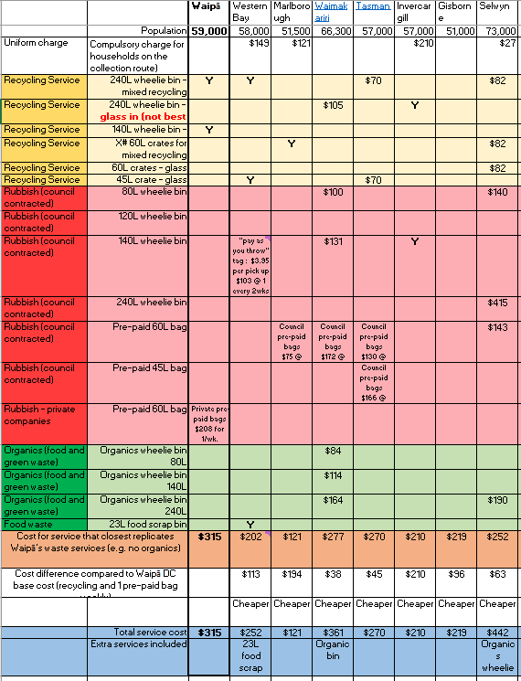

Table 15. Waste Service costs from similar sized councils. Can be viewed in ECM [here](https://waipadc.t1cloud.com/T1Default/CiAnywhere/Web/WAIPADC/RedirectToFunction?sk.DocumentSetId=10759021&f=%24EMC.DOC.PROP.MNT&suite=ECM&h=DoWkeXOWIs&t=12C9C772.) (internal staff only).

## 11.3 Appendix 3: Consultation with Medical Officer of Health

[ECM link](https://waipadc.t1cloud.com/T1Default/CiAnywhere/Web/WAIPADC/RedirectToFunction?sk.DocumentSetId=10801326&f=%24EMC.DOC.PROP.MNT&suite=ECM&h=ayP85ms2FD&t=1303A64D.) to PDF letter that is copied below (internal staff only).

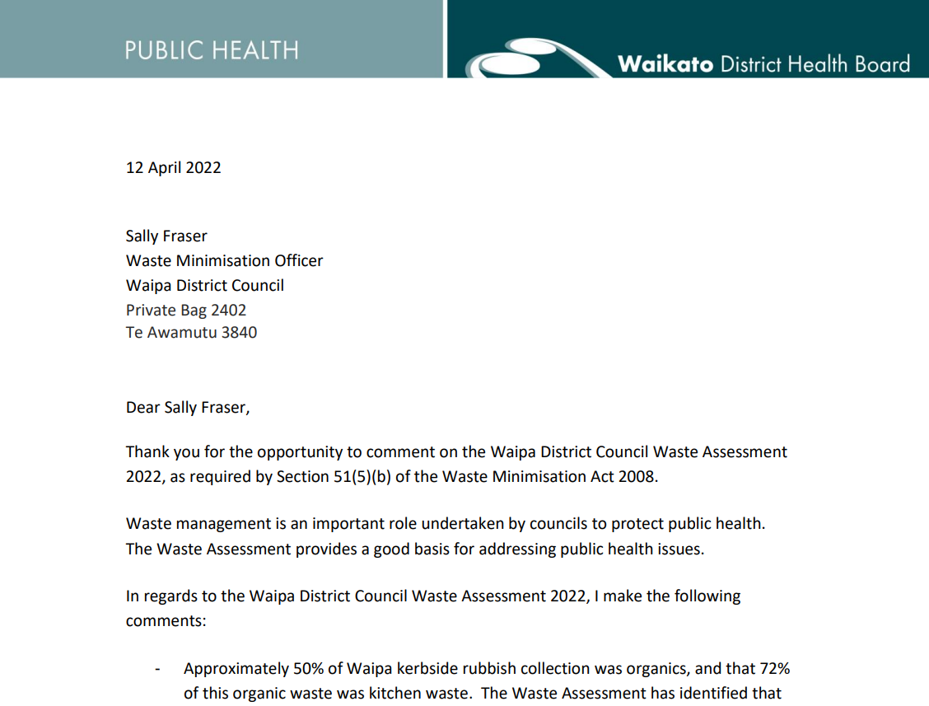

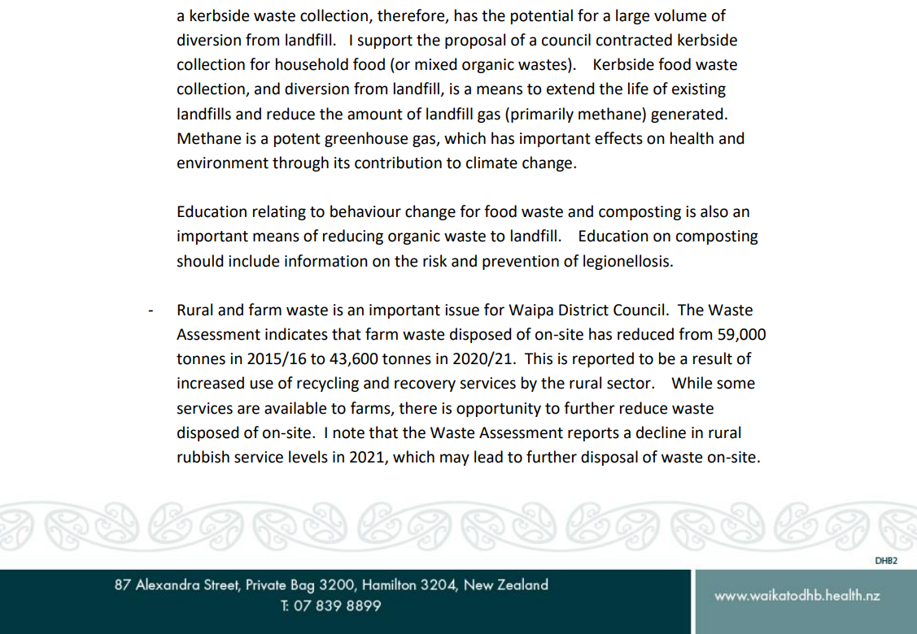

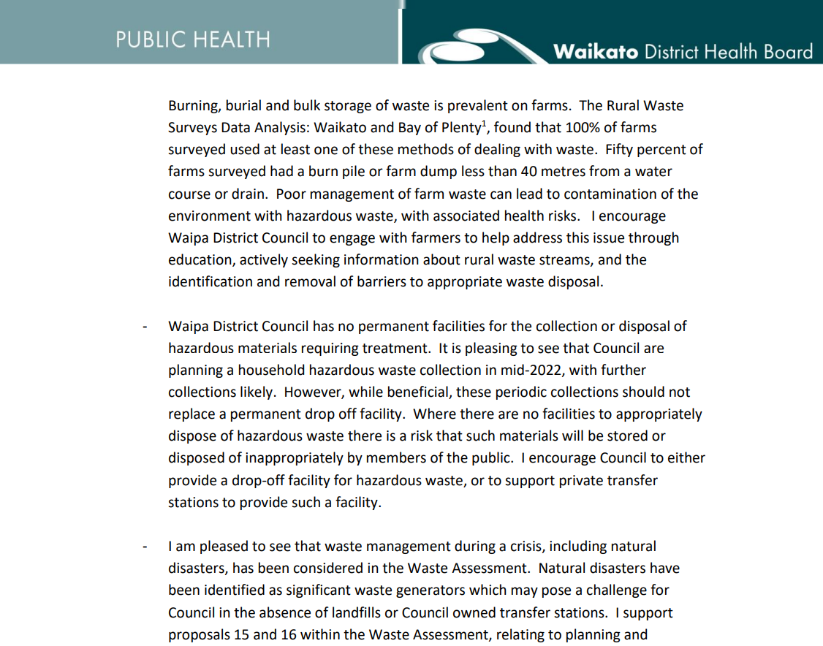

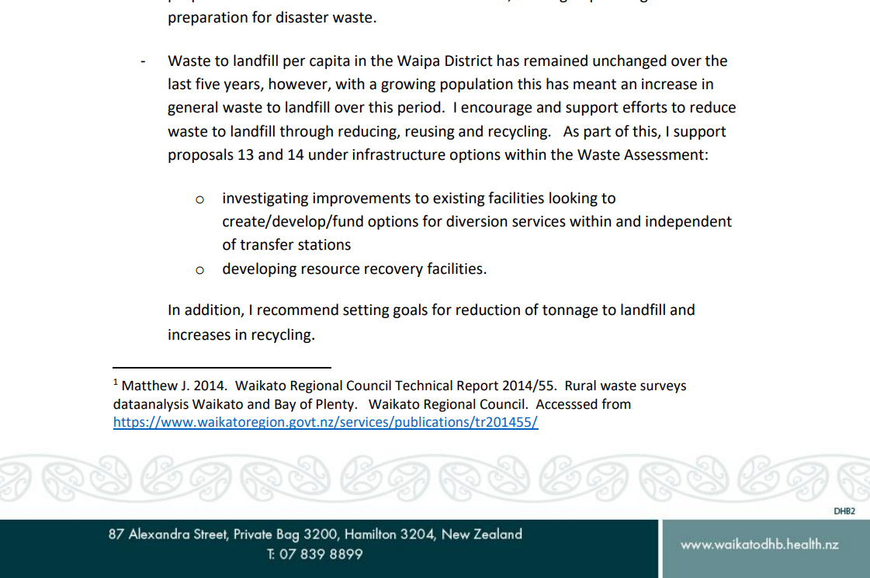

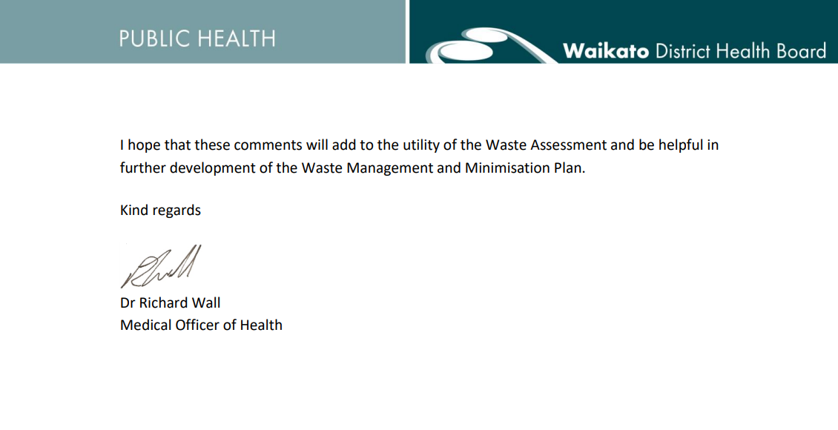

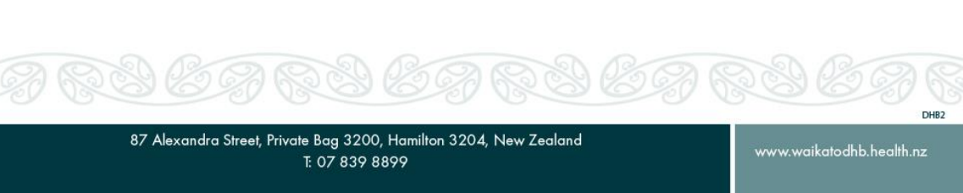

1.
2.
3. NIDEA 2021 SA2 population projections