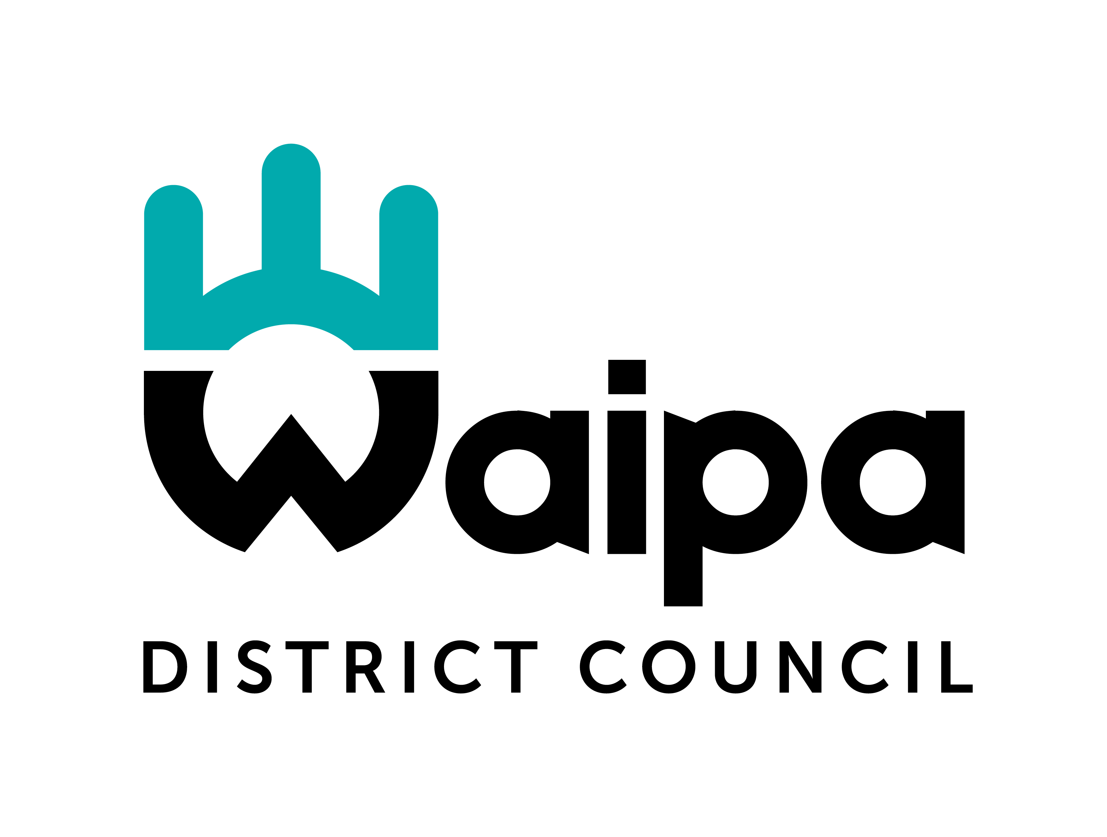
APPENDIX A – WATERMAIN SHUTDOWN REQUEST FORM
(Prior to shutdown) Form: 5421148
APPLICANT TO COMPLETE:
Company:
Contact name:
Contact number:
Details of shutdown:
Contract No:
Requested date & time of shutdown:
Alternative date & time of shutdown: Should there be unforeseen delays this date will be set aside to complete works. This will need to be included on the on the customer shutdown notification
Location of works:
The proposed schedule is: |  | Start | End
WDC Shutdown |  |  |  |  | (Allow minimum 30 minutes)
Contract Works |  |  |  |  | (Include draining, disinfection, connection etc)
WDC Recharge mains |  |  |  |  | (Allow minimum 30 minutes)
Total Time |  |  |  |  | Maximum 4 Hours
Are new lines tested & disinfected to WDC approval? |  |  |  |  |  | Yes |  | No | N/A
Estimated number of domestic customers affected by proposed closure  Note: it is the applicants job to notify affected parties |  |  |  |  |  | 0-50 |  | 51-100 | 100+
Estimated number of other customers affected by proposed closure |  |  |  |  |  | 0-50 |  | 51-100 | 100+
Number of valves exercised?
Valve ID | Valve Type |  |  | Location Description |  |  | Approved by WDC
PROJECT ENGINEER TO COMPLETE (To be completed before sending on to approvers)
The following approvals & requirements have been satisfied (delete as required)
Highlighted plan showing mains & services to be affected? (Attach plans) |  |  |  |  |  |  |  | Yes |  | No/NA
Approved Contractor & Contact details provided? |  |  |  |  |  |  |  | Yes |  | No/NA
Dialysis patients in affected area? |  |  |  |  |  |  |  | Yes |  | No/NA
Approved Program Methodology attached? See appendix B |  |  |  |  |  |  |  | Yes |  | No/NA
Contingency Plan provided? |  |  |  |  |  |  |  | Yes |  | No
Trial Shutdown completed successfully? |  |  |  |  |  |  |  | Yes |  | No
Mains have been flushed, tested, disinfected? (Attach signed copy of results) |  |  |  |  |  |  |  | Yes |  | No/NA
Has contractor met with WDC Retic Staff? |  |  |  |  |  |  |  | Yes |  | No/NA
Connection to council supply within 10 working days of any clearance/bacto sampling? |  |  |  |  |  |  |  | Yes |  | No

APPROVAL
Comments/areas requiring special attention:

Shutdown Card Required: 48 Hours (select one) | Time & date approved:
Public Notification requirements:
Consulting Engineer/Project Engineer/Development Engineer name, date & signature:  Applicant name, date & signature: | Network Team Leader name, date & signature:

APPROVED SHUTDOWN FORM TO BE SENT TO APPLICANT PRIOR TO SHUTDOWN

